Western Australia

Iron Ore Processing (Mineralogy Pty. Ltd.) Agreement Act 2002

Western Australia
Iron Ore Processing (Mineralogy Pty. Ltd.) Agreement Act 2002
Contents
1. Short title 1
2. Commencement 1
3. Interpretation 1
4. Agreement ratified and implementation authorised 2
5. State empowered under clause 27 2
6. Variation agreement ratified and implementation authorised 2
Schedule 1 — Iron Ore Processing (Mineralogy Pty. Ltd.) Agreement
Schedule 2 — Variation agreement
Notes
Compilation table 105

Western Australia
Iron Ore Processing (Mineralogy Pty. Ltd.) Agreement Act 2002
An Act to ratify, and authorise the implementation of, an agreement between the State and Mineralogy Pty. Ltd., Austeel Pty. Ltd., Balmoral Iron Pty. Ltd., Bellswater Pty. Ltd., Brunei Steel Pty. Ltd., International Minerals Pty. Ltd. and Korean Steel Pty. Ltd. relating to the mining and processing of iron ore, predominantly as magnetite, and the transporting of processed iron ore in the Pilbara region, and the establishment of new port facilities in the Pilbara region and the shipping of processed iron ore through those facilities.

1. Short title
This Act may be cited as the Iron Ore Processing (Mineralogy Pty. Ltd.) Agreement Act 2002.

2. Commencement
This Act comes into operation on the day on which it receives the Royal Assent.

3. Interpretation
In this Act —
the Agreement means the Iron Ore Processing (Mineralogy Pty. Ltd.) Agreement, a copy of which is set out in Schedule 1, and includes the agreement as varied from time to time in accordance with its provisions;
variation agreement means the agreement a copy of which is set out in Schedule 2.
[Section 3 amended: No. 48 of 2008 s. 4.]

4. Agreement ratified and implementation authorised
(1) The Agreement is ratified.
(2) The implementation of the Agreement is authorised.
(3) Without limiting or otherwise affecting the application of the Government Agreements Act 1979, the Agreement operates and takes effect despite any other Act or law.

5. State empowered under clause 27
The State has power in accordance with clause 27 of the Agreement.

6. Variation agreement ratified and implementation authorised
(1) The variation agreement is ratified.
(2) The implementation of the variation agreement is authorised.
(3) Without limiting or otherwise affecting the application of the Government Agreements Act 1979, the variation agreement operates and takes effect despite any other Act or law.
[Section 6 inserted: No. 48 of 2008 s. 5.]

Schedule 1 — Iron Ore Processing (Mineralogy Pty. Ltd.) Agreement
[s. 3]
THIS AGREEMENT is made the fifth day of December 2001
B E T W E E N:
THE HONOURABLE GEOFFREY IAN GALLOP, BEc, MA, MPhil, DPhil, MLA, Premier of the State of Western Australia, acting for and on behalf of the said State and its instrumentalities from time to time (hereinafter called “the State”) of the first part, MINERALOGY PTY. LTD. ACN 010 582 680 a company incorporated in the State of Queensland and having its registered office there at ‘Mineralogy House’, Level 8, 135 Wickham Terrace, Spring Hill (hereinafter called “the Company” in which term shall be included its successors and permitted assigns) of the second part, AUSTEEL PTY. LTD. ACN 058 430 032 a company incorporated in the State of Queensland and having its registered office in Western Australia at Level 4 ‘St Georges Square’, 225 St Georges Terrace, Perth of the third part, BALMORAL IRON PTY. LTD. ACN 058 429 931 a company incorporated in the State of Queensland and having its registered office there at ‘Mineralogy House’ Level 8, 135 Wickham Terrace, Spring Hill of the fourth part, BELLSWATER PTY. LTD. ACN 058 429 708 a company incorporated in the State of Queensland and having its registered office there at ‘Mineralogy House’ Level 8, 135 Wickham Terrace, Spring Hill of the fifth part, BRUNEI STEEL PTY. LTD. ACN 058 429 977 a company incorporated in the State of Queensland and having its registered office there at ‘Mineralogy House’ Level 8, 135 Wickham Terrace, Spring Hill of the sixth part, INTERNATIONAL MINERALS PTY. LTD. ACN 058 341 638 a company incorporated in the State of Queensland and having its registered office there at ‘Mineralogy House’ Level 8, 135 Wickham Terrace, Spring Hill of the seventh part and KOREAN STEEL PTY. LTD. ACN 058 429 600 a company incorporated in the State of Queensland and having its registered office there at ‘Mineralogy House’ Level 8, 135 Wickham Terrace, Spring Hill of the eighth part (the parties of the third to eighth parts being hereinafter called “the Co-Proponents” in which term shall be included their respective successors and permitted assigns).
W H E R E A S:
(a) The Company is the holder of mining tenements in the Pilbara region;
(b) The Company has granted various rights in relation to certain of the said mining tenements to the Co-Proponents as set out in the Subsidiary agreements (as hereinafter defined);
(c) The Company by itself or in conjunction with one or more of the Co-Proponents wishes to develop projects incorporating -
(i) the mining and concentration of iron ore in Area A (as hereinafter defined);
(ii) the processing of that iron ore predominantly as magnetite in Area A or elsewhere in the Pilbara region principally for the production and sale of high grade pellets, direct reduced iron and/or hot briquetted iron or steel;
(iii) the transport of magnetite concentrates and processed iron ore within the Pilbara region;
(iv) the establishment of new port facilities in the Pilbara region; and
(v) the shipping of processed iron ore through such port facilities;
(d) The State, for the purpose of promoting employment opportunity and industrial development in Western Australia, has agreed to assist the establishment of the proposed projects upon and subject to the terms of this Agreement.
NOW THIS AGREEMENT WITNESSES:
Definitions
1. In this Agreement subject to the context -
“advise”, “apply”, “approve”, “approval”, “consent”, “certify”, “direct”, “disclose”, “notify”, “request”, or “require”, means advise, apply, approve, approval, consent, certify, direct, disclose, notify, request, or require in writing as the case may be and any inflexion or derivation of any of those words has a corresponding meaning;
“Ancillary Tenement” means any mining tenement that may be granted under the Mining Act to the Company pursuant to its applications for general purpose leases 08/51 to 08/55 and its application for miscellaneous licence 08/20 and according to the requirements of the context shall describe the area of land demised as well as the instrument by which it is demised;
“approved proposal” means a proposal approved or deemed to be approved under this Agreement;
“Area A” means -
(a) such portions of the areas near Cape Preston shown coloured red on Sheet 1 of Plan 1 as are from time to time held by the Company under -
(i) mining leases 08/118 - 08/130 and 08/264 - 08/266;
(ii) exploration licences 08/117, 08/118, 08/636 and 08/660;
(iii) the exploration licence granted under subclause (1) of Clause 9 in respect of the land previously the subject of exploration licence 08/643;
(iv) the Ancillary Tenements;
(v) any mining tenements issued to the Company in substitution for the mining tenements set forth in paragraphs (i) to (iv) of this definition; or
(vi) any other titles to areas within the land coloured red on Sheet 1 of Plan 1 granted to the Company in accordance with the approved proposals; and
(b) any mining lease included in Area A pursuant to subclause (7) of Clause 9;
“Area B1” means the areas near Robe River coloured light green and marked “Area B1” on Plan 1 comprising the exploration licences granted under subclause (4) of Clause 9 in respect of the land previously the subject of exploration licences 47/636, 47/637 and 47/638;
“Area B2” means the areas coloured light blue and marked “Area B2” on Sheet 1 of Plan 1 and comprising exploration licences 08/691 and 08/698;
“Area C” means the area coloured blue and marked “Area C” on Plan 2;
“Area D” means the area coloured light blue and marked “Area D” on Plan 2;
“Clause” means a clause of this Agreement;
“commencement date” means the date the Bill referred to in Clause 3 comes into operation as an Act;
“Common Use Land” means land the subject of or proposed to be the subject of any lease, licence, easement or other title granted under this Agreement the use of which is shared by Projects or is proposed to be so shared in accordance with approved proposals;
“Commonwealth” means the Commonwealth of Australia and includes the Government for the time being thereof;
“Company’s workforce” means the persons (and the dependants of those persons) engaged whether as employees, agents or contractors in the Project Proponents’ activities under this Agreement in respect of Projects hereunder or any of them and includes the persons (and the dependants of those persons) involved in the construction phases of the Projects;
“Department” means the instrumentality of the State from time to time assisting the Minister of the State responsible for the administration of the Mining Act;
“DRI” means direct reduced iron and includes HBI;
“EP Act” means the Environmental Protection Act 1986;
“existing mining leases” means mining leases 08/118 to 08/130;
“Export Credit Agency” means any government agency or government owned entity, statutory body or government controlled body to which the Company or any of the Co-Proponents intend to apply for financial support, financial guarantees or finance to support the construction or development of any project proposal submitted for approval under this Agreement;
“further mining leases” means any mining leases included in Area A pursuant to subclause (7) of Clause 9;
“Government Agreement” means a Government agreement as defined in section 2 of the Government Agreements Act 1979;
“HBI” means DRI in the form of hot briquetted iron;
“high grade fine ore” means iron ore of a nominal size of less than 6 millimetres with an iron content of greater than 60% in its natural state;
“Indicated Mineral Resource” has the meaning given to it in the Reporting Code;
“iron ore concentrates” mean iron ore mined by Project Proponents pursuant to this Agreement and concentrated by them to at least 65% Fe;
“LA Act” means the Land Administration Act 1997;
“local government” means a local government established under the Local Government Act 1995;
“magnetite” means iron ore concentrates in the form of magnetite;
“Mining Act” means the Mining Act 1978;
“Mining Leases” means existing mining leases and further mining leases that have been dedicated to a Project and any mining leases granted pursuant to Clause 10 and according to the requirements of the context shall describe the area of land demised as well as the instrument by which it is demised;
“Minister” means the Minister in the Government of the State for the time being responsible for the administration of the Act to ratify this Agreement and pending the passing of that Act means the Minister for the time being designated in a notice from the State to the Company and includes the successors in office of the Minister;
“Minister for Mines” means the Minister in the Government of the State for the time being responsible for the administration of the Mining Act;
“month” means calendar month;
“native title rights and interests” has the meaning given to it in the Native Title Act 1993 of the Commonwealth;
“notice” means notice in writing;
“person” or “persons” includes bodies corporate;
“Plan 1” and “Plan 2” mean respectively the plans marked “1” and “2” initialled by or on behalf of the parties hereto for the purpose of identification;
“Plant areas” means areas on which Project Proponents may establish processing, port and associated facilities for production and/or shipping in accordance with approved proposals in Area A or other area in the Pilbara agreed to between the Minister and the Company;
“private roads” means the roads referred to in subclause (1) of Clause 13 and any other roads (whether within or outside any areas held by the Company pursuant to this Agreement) constructed by Project Proponents in accordance with an approved proposal or agreed by the State and the Project Proponents to be a private road for the purposes of this Agreement;
“Project 1” means a project or projects for the production of high grade iron ore pellets within Western Australia with subject to Clause 2(h) an initial minimum production capacity of six million tonnes per annum (or lesser amount approved by the Minister) from a mine or mines within Area A and a pellet production facility located within Area A (or other area in the Pilbara region agreed to between the Minister and the Project Proponents) including expansions of projects the subject of approved proposals from time to time and may include inter alia a mine, concentrator, port, desalination plant, pellet plant, power station, pipelines and any other necessary facilities to enable pellets to be produced transported and shipped and provision for the supply of a minor tonnage of iron ore concentrates for use as heavy media in the coal washing industry;
“Project 2” means a project or projects for the production of DRI within Western Australia with subject to Clause 2(h) an initial minimum production capacity of two million tonnes per annum (or lesser amount approved by the Minister) from a mine or mines within Area A and a DRI production facility located within Area A (or other area in the Pilbara region agreed to between the Minister and the Project Proponents) including expansions of projects the subject of approved proposals from time to time and may include inter alia a mine, concentrator, power station, desalination plant, pellet plant, DRI plant, port, pipelines and any other necessary facilities to enable DRI to be produced transported and shipped and provision for the supply of a minor tonnage of iron ore concentrates for use as heavy media in the coal washing industry;
“Project 3” means a project or projects for the production of steel within Western Australia with subject to Clause 2(h) an initial minimum production capacity of two million tonnes per annum (or lesser amount approved by the Minister) from a mine or mines within Area A and a DRI production facility located within Area A (or other area in the Pilbara region agreed to between the Minister and the Project Proponents) including expansions of projects the subject of approved proposals from time to time and may include inter alia a mine, concentrator, power station, desalination plant, pellet plant, DRI plant, steel making and rolling plant, port, pipelines and any other necessary facilities to enable steel to be produced transported and shipped and provision for the supply of a minor tonnage of iron ore concentrates for use as heavy media in the coal washing industry;
“Project” means a project of the type of Project 1, Project 2 or Project 3 the subject of approved proposals or a project made up of a combination of projects of the type of Project 1, Project 2 and/or Project 3 which subject to Clause 2(h) includes an aggregate production capacity of a minimum of six million tonnes per annum (or lesser amount approved by the Minister) of iron ore concentrates for input into a plant or plants the subject of Project 1, Project 2 or Project 3;
“Project Proponents” means in relation to each Project hereunder the Company or, where the proposals for a Project are submitted by the Company and a Co-Proponent or Co-Proponents, the Company and that Co-Proponent or those Co-Proponents;
“public road” means a road as defined by the Road Traffic Act 1974;
“Reporting Code” means the Australasian Code for Reporting of Identified Mineral Resources and Ore Reserves, published by the Australasian Institute of Mining and Metallurgy, the Australian Institute of Geoscientists and the Minerals Council of Australia in July 1996 or any future superseding code issued by the same or any future equivalent organisation or organisations;
“subclause” means subclause of the Clause in which the term is used;
“Subsidiary agreements” means the deeds and agreements set out in the First Schedule to this Agreement;
“this Agreement” “hereof” and “hereunder” refer to this Agreement whether in its original form or as from time to time added to varied or amended;
“wharf” includes any jetty structure.
Interpretation
2. In this Agreement -
(a) monetary references are references to Australian currency unless otherwise specifically expressed;
(b) power given under any clause other than Clause 34 to extend any period or date shall be without prejudice to the power of the Minister under Clause 34;
(c) Clause headings do not affect the interpretation or construction;
(d) words in the singular shall include the plural and words in the plural shall include the singular according to the requirements of the context;
(e) one gender includes the other genders;
(f) reference to an Act includes the amendments to that Act for the time being in force and also any Act passed in substitution therefor or in lieu thereof and the regulations for the time being in force thereunder;
(g) every covenant or agreement expressed or implied in this Agreement in which more persons that one covenant and agree shall bind such persons and every two or more of them jointly and each of them severally; and
(h) the provisions for minimum production capacities contained in the definitions of Project 1, Project 2, Project 3 and Project (in relation to a combination of projects) in Clause 1 shall only apply to the first project of the type of Project 1, Project 2 or Project 3 or a combination thereof which is approved under Clause 7.
Initial obligations of the State
3. The State shall -
(a) introduce by 31 December 2001 and sponsor a Bill in the Parliament of Western Australia to ratify this Agreement and endeavour to secure its passage as an Act prior to 30 June 2002 or such later dates as may be agreed between the parties hereto; and
(b) subject to the adequate protection of the environment (including flora and fauna), the land affected (including improvements thereon) and sites of aboriginal significance allow the Company and any Co-Proponent to enter upon Crown Lands (including, if applicable, land the subject of a pastoral lease) to the extent reasonably necessary for the purposes of undertaking their obligations under subclause (1) of Clause 5.
Ratification and operation
4. (1) The provisions of this Agreement other than this Clause and Clauses 1, 2 and 3 shall not come into operation until the Bill referred to in Clause 3 has been passed by the Parliament of Western Australia and comes into operation as an Act.
(2) If before 30 June 2002 or such later agreed date the said Bill has not commenced to operate as an Act then, unless the parties hereto otherwise agree, this Agreement shall then cease and determine and no party hereto shall have any claim against any other party hereto with respect to any matter or thing arising out of, done, performed, or omitted to be done or performed under this Agreement.
(3) On the said Bill commencing to operate as an Act, this Agreement shall operate and take effect according to its terms notwithstanding the provisions of any Act or law of Western Australia.
Initial obligations of the Company
5. (1) The Company shall keep the State fully informed as to the progress and results of its field and office geological, geotechnical, engineering, environmental, heritage, marketing and finance studies and other matters necessary to enable it and any Co-Proponent to finalise and to submit the proposals referred to in Clause 6 in respect of the first project of the type of Project 1, the first project of the type of Project 2 and the first project of the type of Project 3 and shall report in writing thereon to the State at quarterly intervals or such longer periods as may be approved by the Minister.
(2) With each report pursuant to subclause (1) the Company shall also advise the State of the then expected Western Australian and other Australian content of each Project and, in relation to each Project, the matters the subject of subclause (4) of Clause 12.
(3) The Company shall co-operate with the State and consult with the representatives or officers of the State regarding matters referred to in subclause (1) and any other relevant studies in relation thereto that the Minister may wish to undertake and shall join with the State in any studies into infrastructure that the Minister and the Company agree should be undertaken.
Project proposals
6. (1) The Company either alone or with a Co-Proponent shall subject to the EP Act and the provisions of this Agreement submit to the Minister on or before 30 June 2003 to the fullest extent reasonably practicable its detailed proposals (including plans where practicable and specifications where reasonably required by the Minister and any other details normally required by the local government in which area any of the works are to be situated) for a project or projects of the type of Project 1, Project 2 or Project 3 or a combination thereof as described in the definition of Project in Clause 1. Thereafter during the currency of this Agreement the Company either alone or with a Co-Proponent may subject as aforesaid make further such detailed proposals for new projects of the type of Project 1, Project 2 or Project 3 or a combination thereof as aforesaid. The detailed proposals made pursuant to this Clause in respect of a project are in this Agreement called a “Project proposal”.
(2) Each Project proposal shall address the establishment and operation of the project concerned and make provision where appropriate for the Company’s workforce required to enable the Project Proponents to mine, recover and process iron ore and shall include the location, area, lay-out, design, quantities, materials and time programme for the commencement and completion of construction or the provision (as the case may be) of each of the following matters, if and as they are applicable to the project namely -
(a) (i) the mining and recovery of iron ore and any other minerals necessary for use in the project, including mining crushing screening concentration handling transport and storage of iron ore and plant facilities; and
(ii) any portion of Area A that the Project Proponents wish to be included in a mining lease to be issued to the Company pursuant to Clause 10 in respect of the project and any existing mining lease or leases or further mining lease or leases or Ancillary Tenement, or part thereof, the subject of a sublease approved by the Minister under Clause 31 or a sublease or a right to mine under the Subsidiary agreements, which the Project Proponents propose to be dedicated to the project;
(b) the plant or plants comprising the project the subject of the Project proposal for processing of iron ore and the estimated capital cost of the project;
(c) accommodation and ancillary facilities for the Company’s workforce;
(d) temporary accommodation and ancillary facilities for the construction workforce for the project;
(e) water supply for process and other uses including water intake to and discharge from any desalination plant and process plants;
(f) electricity and gas supply and transmission;
(g) transportation of iron ore concentrates and/or products of iron ore concentrates;
(h) dewatering of slurry and re-use of water;
(i) disposal of waste rock and tailings;
(j) Plant areas and construction lay-down areas;
(k) Common Use Land;
(l) production of final products from iron ore concentrates by pelletising and/or direct reduction and/or steel making and disposal of residues;
(m) port development works including wharf, jetty and causeway works, dredging and dredge spoil disposal and storage and ship loading of the final products;
(n) proposed infrastructure including causeways and corridors for roads, railway (if applicable), pipelines, transmission lines and conveyors;
(o) any other works, services or facilities desired by the Project Proponents;
(p) use of local labour professional services manufacturers suppliers contractors and materials and measures to be taken with respect to the engagement and training of employees by the Project Proponents and their agents and contractors; and
(q) any leases, licences or other tenures of land in favour of the Company required from the State in respect of the project or for Common Use Land.
Order of proposals
(3) The proposals constituting a Project proposal may with the approval of the Minister or if so required by the Minister shall be submitted separately and in any order as to the matter or matters mentioned in one or more of paragraphs (a) to (q) of subclause (2).
Use of existing infrastructure
(4) Each Project proposal may with the consent of the Minister and that of any other parties concerned instead of providing for the construction of new facilities or equipment or the provision of new services of the kind therein mentioned provide for the use by the Project Proponents of any existing facilities equipment or services of such kind belonging to the Company or the Project Proponents or, upon terms and conditions agreed between the Company or the Project Proponents as the case may be and the other parties concerned, of any other existing facilities equipment or services of such kind.
Development of Cape Preston
(5) (a) Proposals submitted pursuant to subclause (1) for Plant areas in respect of any area within Area C and Area D or either of them shall make reasonable provision for future third party use of port facilities as provided for in subclause (3) of Clause 21 by providing for the development of the Plant areas so far as practicable in Area C and providing for access to Cape Preston.
(b) Where it is necessary to develop Plant areas in Area D the Company or the Project Proponents as the case may require shall make allowances for use by others of areas in Area D for industrial purposes and access therefrom to Cape Preston.
Additional submissions
(6) At the time when Project Proponents submit each Project proposal pursuant to this Clause they shall -
(a) submit to the Minister details of any services (including any elements of the project investigations design and management) and any works materials plant equipment and supplies that they propose to consider obtaining from or having carried out or permitting to be obtained from or carried out outside Australia together with their reasons therefor and shall, if required by the Minister, consult with the Minister with respect thereto; and
(b) subject to subclause (7), demonstrate to the Minister’s satisfaction -
(i) the availability of finance necessary to carry out and complete the project the subject of the Project proposal; and
(ii) the readiness of the Project Proponents in all other respects to commence, complete and thereafter operate the project the subject of the Project proposal.
(7) If the Project Proponents notify the Minister at the time they submit a Project proposal that they or one or more of them are applying to an Export Credit Agency for financial support in connection with the project the subject of the Project proposal, the Minister shall proceed with consideration of the Project proposal pursuant to Clause 7 and the time for the Project Proponents’ compliance with subclause (6)(b) shall be extended to a maximum of 18 months from the date of the notification of the application to the Minister or the earlier withdrawal of the application and, notwithstanding any provision to the contrary in this Agreement, until compliance by the Project Proponents with subclause (6)(b) -
(a) any approval by the Minister of the Project proposal may be given subject to such compliance; and
(b) any requirement upon the State to grant any lease licence or other title in relation to the project the subject of the Project proposal shall be suspended.
(8) If the Minister is not satisfied with any details provided pursuant to paragraph (b)(i) or (ii) of subclause (6) (whether under subclause (6) or (7)) he shall notify the Project Proponents of this within 30 days of receipt by him of those details and shall afford the opportunity to the Project Proponents to submit further or different evidence in relation thereto for his consideration. The Project Proponents may submit to arbitration under this Agreement the question of the reasonableness of the Minister’s decision on any evidence submitted pursuant to paragraph (b)(i) or (ii) of subclause (6) or this subclause.
Consideration of proposals
7. (1) Subject to the EP Act in respect of each proposal submitted pursuant to Clause 6 the Minister shall -
(a) approve of the proposal without qualification or reservation; or
(b) defer consideration of or decision upon the same until such time as the Project Proponents submit a further proposal or proposals in respect of some other of the matters mentioned in subclause (2) of Clause 6 not covered by the said proposal; or
(c) require as a condition precedent to the giving of his approval to the said proposal that the Project Proponents make such alteration thereto or comply with such conditions in respect thereto as he thinks reasonable PROVIDED THAT -
(i) no such alteration or conditions shall require the Project Proponents to grant access to their mineral resources to any third party; and
(ii) the Minister shall disclose his reasons for such alteration or conditions,
PROVIDED ALWAYS that where implementation of any proposals hereunder have been approved pursuant to the EP Act subject to conditions or procedures, any approval or decision of the Minister under this Clause shall, if the case so requires, incorporate a requirement that the Project Proponents make such alterations to the proposals as may be necessary to make them accord with those conditions or procedures.
Advice of Minister’s decision
(2) The Minister shall within two months after receipt of proposals pursuant to Clause 6 give notice to the Project Proponents of his decision in respect to the proposals PROVIDED THAT -
(a) where a proposal is to be assessed under section 40(1)(b) of the EP Act the Minister shall be required to give notice to the Project Proponents of his decision in respect to the proposal within 2 months after the later happening of the receipt of the proposal and the service on him of an authority under section 45(7) of the EP Act; and
(b) where implementation of a proposal by the State will or may require the State to do any act which affects any native title rights and interests the Minister shall be required to give notice to the Project Proponents of his decision in respect to the proposal not later than 2 months after the later happening of the receipt of the proposal and the completion of all processes required by laws relating to native title to be undertaken by the State before that act may be done by the State.
Consultation with Minister
(3) If the decision of the Minister is as mentioned in either of paragraphs (b) or (c) of subclause (1) the Minister shall afford the Project Proponents full opportunity to consult with him and should they so desire to submit new or revised proposals either generally or in respect to some particular matter.
Minister’s decision subject to arbitration
(4) If the decision of the Minister is as mentioned in either of paragraphs (b) or (c) of subclause (1) and the Project Proponents consider that the decision is unreasonable the Project Proponents within two months after receipt of the notice mentioned in subclause (2) may elect to refer to arbitration in the manner hereinafter provided the question of the reasonableness of the decision PROVIDED THAT any requirement of the Minister pursuant to subclause (1) that the Project Proponents shall alter their proposals to accord with conditions or procedures the subject of an approval pursuant to the EP Act shall not be referable to arbitration hereunder.
Arbitration award
(5) An award made on an arbitration pursuant to subclause (4) shall have force and effect as follows -
(a) if by the award the dispute is decided against the Project Proponents then the Project Proponents shall be deemed to have accepted such award unless within 3 months after delivery of the award the Project Proponents give notice to the Minister that they do not accept the award. If the Project Proponents give such notice this Agreement shall on the expiration of that period of 3 months cease and determine as regards the project the subject of the Project proposal and, in relation to the Project proposal, the person or persons who submitted the Project proposal and neither the State nor that person or those persons shall have any claim against the other of them with respect to the Project proposal or the project the subject thereof or any matter or thing arising out of done performed or omitted to be done or performed under this Agreement in relation thereto; or
(b) if by the award the dispute is decided in favour of the Project Proponents the decision shall take effect as (and be deemed to be) a notice by the Minister that he is so satisfied with and approves the matter or matters the subject of the arbitration.
Implementation of proposals
(6) In respect of each proposal hereunder the Project Proponents in relation thereto shall subject to and in accordance with the EP Act and any approvals and licences required under that Act implement the approved proposals in respect of the Project in accordance with the terms thereof and subject to marketing arrangements and reasonable maintenance and operational shut down requirements the Project Proponents shall ensure continuous operation of the Project.
Effect of non-approval of proposals
(7) Notwithstanding any provision of this Agreement or that under this Clause any proposals of Project Proponents are approved by the Minister or deemed to be approved as a consequence of an arbitration award, unless each and every proposal and matter required pursuant to Clause 6 in respect of a project proposal for one project (being a project of the type of Project 1, Project 2 or Project 3 or a combination thereof as described in the definition of Project in Clause 1) is so approved or deemed to be approved by 30 June 2004 then the Minister may give to the Company and the Co-Proponents 12 months notice of intention to determine this Agreement and unless before the expiration of the said 12 months period detailed proposals in respect of one such project are so approved or deemed to be approved this Agreement shall on the expiration of that period cease and determine subject however to the provisions of Clause 36.
Additional proposals
8. (1) If Project Proponents at any time during the continuance of this Agreement desire to significantly modify expand or otherwise vary their activities carried on pursuant to this Agreement in relation to a Project beyond those activities specified in the approved proposals relating to that Project they shall give notice of such desire to the Minister and within 2 months thereafter shall submit to the Minister detailed proposals in respect of all matters covered by such notice and such of the other matters mentioned in paragraphs (a) to (q) of subclause (2) of Clause 6 as are applicable to the Project and as the Minister may require.
(2) The provisions of Clause 6 and Clause 7 (other than subclauses (5)(a), (6) and (7)) shall mutatis mutandis apply to detailed proposals submitted pursuant to this Clause with the proviso that the Project Proponents may withdraw such proposals at any time before approval thereof or, where any decision of the Minister in respect thereof is referred to arbitration, within 3 months after the award by notice to the Minister that they shall not be proceeding with the same. The Project Proponents shall subject to and in accordance with the EP Act and any approvals and licences required under that Act implement approved proposals pursuant to this Clause in accordance with the terms thereof.
Mining tenements - Area A
9. (1) As soon as reasonably possible after the commencement date the State shall cause to be granted to the Company an exploration licence in respect of all the land previously the subject of exploration licence 08/643 on the terms and conditions that applied to that licence (including endorsement of authority to explore for iron) as modified in subclause (2).
(2) During the currency of this Agreement until, in the case of an existing mining lease or further mining lease, dedication thereof to one of the Projects and, in any other case, surrender of the tenement by the Company each of the mining tenements comprising Area A shall, subject to compliance by the Company with the terms and conditions applicable thereto (as modified by this Clause), be held under and subject to the Mining Act modified as follows -
(a) as regards existing mining leases 08/118 to 08/130, the rents payable in respect thereof during the period from the grant thereof to the date of this Agreement shall be at the rate applicable to retention licences and during the period from the date of this Agreement to 31 December 2001 shall be at the rate applicable to exploration licences;
(b) as regards all the mining tenements -
(i) the Company shall not be required to comply with any expenditure conditions imposed by or under the Mining Act in regard thereto;
(ii) any assignment, underletting or parting with possession of the mining tenement shall be subject to Clause 31; and
(c) (i) in respect of mining leases and any Ancillary Tenements, the Company shall be entitled to a second renewal of the terms thereof for a further period of 21 years;
(ii) in respect of exploration licences, the Company shall be entitled to annual extensions during the term of this Agreement and the provisions of section 65 of the Mining Act shall not apply thereto; and
(iii) on the cessation or determination of this Agreement any existing mining lease and further mining lease (not being a mining lease which has been dedicated to a Project) then within Area A and any Ancillary Tenement shall continue in force under and subject to the Mining Act for the balance of its unexpired term and any exploration licence then within Area A shall thereupon be deemed to be an exploration licence granted under the Mining Act on the date of cessation or determination of this Agreement and the Mining Act shall apply thereto accordingly.
(3) Any rent paid by the Company in respect of the mining leases referred to in paragraph (a) of subclause (2) in excess of the rent required pursuant to that paragraph shall be refunded to the Company as soon as possible following the commencement date.
Area B1
(4) As soon as reasonably possible after the commencement date the State shall cause to be granted to the Company exploration licences in respect of all the land previously the subject of exploration licences 47/636, 47/637 and 47/638.
(5) The exploration licences granted under subclause (4) shall, subject to compliance by the Company with the terms and conditions applicable thereto (as modified by this Clause), be held under and subject to the Mining Act (with endorsement of authority to explore for iron) modified as follows -
(a) the deletion of section 65;
(b) the term of each exploration licence shall be five years from the date of grant;
(c) the Company shall not be required to comply with any expenditure condition imposed by or under the Mining Act in regard thereto;
(d) any assignment, underletting or parting with possession thereof shall be subject to Clause 31;
(e) if this Agreement ceases or determines during the term of an exploration licence to which this Clause applies, the exploration licence shall continue in force under and subject to the Mining Act for the balance of the term then current.
Area B2
(6) The provisions of subclause (5) shall apply to each of the exploration licences comprising Area B2 mutatis mutandis and as if the word “five” in paragraph (b) of subclause (5) were deleted and substituted by the word “ten”.
Inclusion in Area A
(7) If from time to time iron ore in an area within Area B1 or B2 is proved up to at least Indicated Mineral Resource status or an area within Area B1 or B2 has been otherwise explored for iron ore to the satisfaction of the Minister and the Company holds a mining lease in respect of the area, the Company may apply to the Minister for such a mining lease to be included in Area A and provided the aggregate area of Area A, any Mining Leases granted pursuant to Clause 10 and the area of the mining lease sought to be included in Area A shall not exceed 777 square kilometres the Minister will include the portion or portions applied for in Area A. The Company may surrender land within Area A to reduce the area thereof for the purpose of this subclause and the provisions of paragraph (c)(ii) of subclause (8) shall apply mutatis mutandis to any such surrender.
Withdrawal of tenements
(8) (a) Subject to paragraph (c) of this subclause the Company with the consent of the Minister may from time to time withdraw from Area A any mining tenement held by the Company or part thereof within Area A other than a mining lease dedicated to a Project or a mining lease granted pursuant to Clause 10 or surrender such a tenement or part thereof to the State Provided That the Minister will consent thereto if -
(i) the tenement is not the whole or part of mining leases 08/123 to 08/125; and
(ii) the Company has provided to the Minister a Mineral Resources report signed by a Competent Person as defined in the Reporting Code which confirms that there will be sufficient Indicated Mineral Resource of magnetite of appropriate quality and grade remaining in Area A following the proposed withdrawal of a tenement or part thereof to provide for the establishment and operation for a minimum of 20 years of a project of the type of Project 1 and a project of the type of Project 2 as contemplated by this Agreement.
(b) Subject to paragraph (c) of this subclause the Company may at any time by notice to the Minister elect to withdraw any exploration licence within Area B1 or Area B2 from the Area or may at any time surrender any such exploration licence or part thereof.
(c) (i) Any withdrawal of a tenement or part thereof pursuant to paragraph (a) or (b) of this subclause is subject to the Company warranting to the State that it has the consent of all Co-Proponents who have any interest in the tenement to the withdrawal.
(ii) Any surrender pursuant to paragraph (a) or (b) of this subclause is subject to the prior surrender by all Co-Proponents who have any interest or interests in the land to be surrendered of those interests.
(d) Any mining tenement withdrawn from an Area pursuant to paragraph (a) or (b) of this subclause shall cease upon such withdrawal to have the benefit of the rights and privileges conferred by this Agreement, and any modification by this Agreement of any Act or law in relation thereto shall cease to apply, but otherwise -
(i) any exploration licence within Area A shall thereupon be deemed to be an exploration licence granted under the Mining Act on the day of withdrawal from this Agreement and the Mining Act shall apply thereto accordingly; and
(ii) all other mining tenements shall continue in force under and subject to the Mining Act for the balance of their then current terms.
Mining leases
10. (1) Where approved proposals in respect of a Project provide for the issue of a mining lease of a portion of Area A the State, on application by the Company not later than 3 months after the proposals have been approved and the Project Proponents have complied with the provisions of subclause (6) of Clause 6 shall, on the surrender of the land applied for out of the relevant mining tenement then held by the Company, cause to be granted to the Company at the rents specified from time to time in the Mining Act (subject to subclause (8)) a mining lease for all minerals including iron of the land so applied for (notwithstanding that the survey in respect thereof has not been completed but subject to such corrections to accord with the survey when completed at the Company’s expense) each such mining lease to be granted under and, except as otherwise provided in this Agreement, subject to the Mining Act but in the form of the Second Schedule to this Agreement and subject to such conditions or stipulations consistent with the provisions of this Agreement and approved proposals as the Minister for Mines with the concurrence of the Minister may determine and to be for a period of 21 years commencing from the date of grant thereof with the right during the currency of this Agreement to take an automatic extension of the said term for two further periods each of 21 years upon the same terms and conditions such extensions to apply upon the Company making written application for the extension not later than one month before the expiration of the then current term of the mining lease.
Existing and further mining leases
(2) (a) Upon approval of proposals under which an existing mining lease or further mining lease becomes dedicated to a Project the term of that mining lease shall thereupon become for a term of 21 years commencing from the date of the approval of those proposals with the right during the currency of this Agreement to take an automatic extension of the said term for two further periods each of 21 years upon the same terms and conditions such extensions to apply upon the Company making written application for the extension not later than one month before the expiration of the then current term of the mining lease.
(b) An existing mining lease or further mining lease or part thereof dedicated to a Project in accordance with approved proposals shall subject to subclause (6) remain dedicated during the term hereof to the Project to which it was dedicated.
Exemption from expenditure conditions
(3) The State shall ensure that during the currency of this Agreement and subject to compliance with its obligations hereunder the Company shall not be required to comply with the expenditure conditions imposed by or under the Mining Act in regard to the Mining Leases.
Reports
(4) The Company shall lodge with the Department in respect of all mining tenements within Area A, Area B1 and Area B2 -
(a) such periodical reports (except reports in the form of Form 5 of the Mining Regulations 1981 or other reports relating to expenditure) and returns as may be prescribed in respect of mining leases or exploration licences as the case may be pursuant to the Mining Act;
(b) if requested by the Department but not more frequently than annually, a report on identified mineral resources and/or ore reserves within the said Areas (using the Reporting Code) together with a list of any geological, geochemical, geophysical, geotechnical and metallurgical activities carried out during the year and, if requested by the Department, will provide details and results of any of those activities in a mineral exploration report, or other technical report, in accordance with the statutory guidelines on reporting as specified in the Mining Act;
(c) reports on drilling operations and drill holes where the main purpose of the drilling was to discover or define future mineral resources and/or ore resources within the said Areas and, if requested by the Department, reports on drilling done within blocks of proven ore for the purpose of mine planning.
Access over Areas A, B1 and B2
(5) The Company the Co-Proponents and the Project Proponents shall at all times permit the State and third parties with the consent of the State (with or without stock, vehicles and rolling stock) to have access to and to pass over Area A, Area B1 and Area B2 (by separate route, road or railway) so long as that access and passage does not unduly prejudice or interfere with the activities of the Company and Project Proponents under this Agreement.
Surrender of part of Mining Leases
(6) Subject to and in accordance with section 95 of the Mining Act and subject to the prior surrender by all Co-Proponents who have any interest or interests in the land to be surrendered of those interests the Company may in relation to any Project from time to time (with abatement of future rent in respect to the area surrendered but without any abatement of rent already paid or any rent which has become due and has been paid in advance) surrender to the State all or any portion or portions of the Mining Leases.
Stone sand clay and gravel
(7) The Project Proponents in accordance with approved proposals may for the construction of works (and the maintenance thereof) within the Mining Leases for the purposes of this Agreement and without payment of royalty, obtain stone sand clay and gravel from the Mining Leases.
Regulation 28A
(8) For the purpose of this Agreement in respect of any Mining Lease regulation 28A of the Mining Regulations 1981 shall be deemed modified -
(a) by deleting “obtained” wherever it occurs and substituting in each place the following -
“removed”;
(b) by inserting the following subregulation -
“(4) Where iron ore from a Mining Lease as defined in the agreement ratified by the Iron Ore Processing (Mineralogy Pty. Ltd.) Agreement Act [ ] is concentrated into iron ore concentrates the rate per tonne under this regulation shall apply to those iron ore concentrates in lieu of the iron ore from which they were concentrated.”.
Royalties
11. (1) The Company shall during the continuance of this Agreement pay to the State royalty on all minerals (other than iron ore, iron ore concentrates, pellets or DRI shipped solely for testing purposes and in respect of which no purchase price or other consideration is payable or due) obtained from the Mining Leases as follows -
(a) on iron ore concentrates processed under this Agreement (hereinafter referred to in this Clause as “the input”) - royalty assessed on the imputed value of the input calculated in accordance with subclause (2) at the relevant royalty rate minus:
(i) 2% - where the input is processed into steel in Western Australia;
(ii) 1% - where the input is processed into DRI but is not further processed into steel in Western Australia; or
(iii) 0.5% - where the input is processed into pellets but is not further processed under this Agreement into DRI;
(b) on other iron ore concentrates and on all other iron ore - royalty as from time to time prescribed under the Mining Act; and
(c) on all other minerals - royalty as from time to time prescribed under the Mining Act.
(2) (a) Unless previously agreed by the Minister and the Company, the imputed value of the input for each financial year commencing on 1 July, will be the average of the free on board sale prices, converted to Australian currency terms at the exchange rate (as defined in paragraph (d) of this subclause) prevailing on 1 July, of Goldsworthy, Hamersley and Mt Newman high grade fine ore adjusted for Fe content sold to Japanese steel mills, as agreed by the relevant producers and consumers for the Japanese financial year which commenced on the immediately preceding 1 April and as quoted in the TEX report or a similar trade journal accepted by the Minister and the Company in place thereof.
(b) The imputed value of the input shall be calculated in respect of each financial year by an officer of the Department of the Public Service of the State principally assisting the Minister for Mines in the administration of the Mining Act appointed by the Minister for Mines for the purpose of this subclause and the Department shall advise the Company of the imputed value as soon as reasonably possible after 1 July.
(c) Where for any reason the imputed value cannot be calculated in accordance with this subclause it will be agreed or determined.
(d) The exchange rate referred to in paragraph (a) of this subclause means the relevant mid-rate published by the Reserve Bank of Australia for the relevant 1 July. If the Reserve Bank of Australia ceases to publish the required information an alternative method to calculate conversions to Australian dollars shall be agreed between the State and the Company.
(3) The Company shall within twenty eight days after the quarter days the last days of March June September and December in each year commencing with the quarter day next following the first date on which minerals the subject of royalty under subclause (1) are disposed of furnish to the Minister for Mines a return showing separately the quantities of input, other iron ore and other minerals the subject of royalty under subclause (1) and disposed of during the quarter immediately preceding the due date of the return and shall not later than one month after such due date pay to the Minister for Mines the royalty payable in accordance with that return in respect of the minerals disposed of in that quarter or if the imputed value has not then been calculated, agreed or determined pay to the Minister for Mines on account of the royalty payable in respect of the input a sum calculated on the basis of the imputed value last calculated, agreed or determined and shall from time to time in the next following appropriate return and payment make (by return and by cash) all such necessary adjustments (and give to the Minister for Mines full details thereof) when the imputed value has been calculated or agreed or determined.
(4) The Company and the Project Proponents shall -
(a) permit the Minister for Mines or his nominee to inspect at all reasonable times the books of account and records of the Company and the Project Proponents including contracts relative to any shipment or sale of minerals and records of minerals in stockpile or transit and to take copies of extracts therefrom and for the purpose of determining the royalty payable in respect of any shipment sale transfer or other disposal or processing of minerals hereunder by the Company and the Project Proponents shall take reasonable steps (i) to provide the Minister for Mines with details and information that may be required by the Minister for Mines for the purpose of calculating, agreeing or determining the imputed value and (ii) to satisfy the State either by certificate of a competent independent party acceptable to the State or otherwise to the reasonable satisfaction of the Minister for Mines as to all relevant weights and analyses and will give due regard to any objection or representation made by the Minister for Mines or his nominee as to any particular weight or assay of minerals which may affect the amount of royalty payable hereunder; and
(b) as and when required by the Minister for Mines from time to time install and thereafter maintain in good working order and condition meters for measuring quantities of minerals of such design or designs and at such places as the Minister for Mines may reasonably require.
(5) (a) If any time not less than 5 years after the first royalty return is submitted under subclause (3), it appears to the Company or the State that the method set out in subclause (2) by which the imputed value is calculated (the “method”) does not produce the true and fair market value of the input either of those parties may give notice to the other party to that effect, setting out the reasons for its belief. After such notice has been given, the Minister and the Company shall consult and endeavour to agree to an alternative method of calculating the imputed value which better represents the true and fair market value of the input (the “alternative method”). If the Minister and the Company are unable to agree an alternative method within 12 months from the date of the notice, either party may then refer to arbitration under this Agreement the determination of the alternative method and the date from which any alternative method shall apply.
(b) Notwithstanding that a notice may have been given under paragraph (a) the calculation of the imputed value shall continue to be made as provided for in the method until an alternative method is agreed or determined by arbitration. Any alternative method may, under an agreement or determination by arbitration, apply from the date on which the notice under paragraph (a) was given or from a later date.
(c) Where an alternative method is agreed or determined by arbitration, the Company shall in the next return and payment of royalty under subclause (3) make (by return and, if the case requires, by cash) all necessary adjustments (and give to the Minister for Mines full details thereof). If any refund of royalty remains due from the State to the Company after such adjustments have been made, the State shall refund such royalty to the Company within one month of receipt by the Minister for Mines of the royalty return setting out the adjustments.
(6) Where used in this Clause -
(a) “agreed or determined” means agreed between the Company and the Minister or, failing agreement within three months of the Minister giving notice to the Company that he requires the value of a quantity of input to be agreed or determined, as determined by the Minister and in agreeing or determining a fair and reasonable market value of such input assessed at an arm’s length basis the Company and/or the Minister as the case may be shall have regard to prevailing markets and prices for high grade fine ore adjusted for Fe content both outside and within the Commonwealth;
(b) “disposed of” means -
(i) for iron ore concentrates processed under this Agreement - input into the pellet plant in the case of a project of the type of Project 1 or input into the DRI plant in the case of a project of the type of Project 2 or Project 3;
(ii) for all other iron ore and all other minerals - obtained from a Mining Lease and shipped, sold, transferred or otherwise disposed of;
(c) “minerals” includes minerals processed or partly processed under this Agreement; and
(d) “relevant royalty rate” means:
(i) for the period ending on the quarter date next following the date 14 years after the commencement date, 5%; and
(ii) for the period after the quarter date next following the date 14 years after the commencement date, the royalty rate from time to time prescribed under the Mining Act for magnetite as if the imputed value of the input was its realized value.
Use of local labour professional services and materials
12. (1) Except as otherwise agreed by the Minister Project Proponents shall, for the purposes of this Agreement -
(a) except in those cases where the Project Proponents can demonstrate it is impracticable so to do, use labour available within Western Australia or if such labour is not available then, except as aforesaid, use labour otherwise available within Australia;
(b) as far as it is reasonable and economically practicable so to do, use the services of engineers surveyors architects and other professional consultants experts and specialists, project managers, manufacturers, suppliers and contractors resident and available within Western Australia or if such services are not available within Western Australia then, as far as practicable as aforesaid, use the services of such persons otherwise available within Australia;
(c) during design and when preparing specifications, calling for tenders and letting contracts for works materials plant equipment and supplies (which shall at all times, except where it is impracticable so to do, use or be based upon Australian Standards and Codes) ensure that suitably qualified Western Australian and Australian suppliers manufacturers and contractors are given fair and reasonable opportunity to tender or quote;
(d) give proper consideration and where possible preference to Western Australian suppliers manufacturers and contractors when letting contracts or placing orders for works, materials, plant, equipment and supplies where price quality delivery and service are equal to or better than that obtainable elsewhere or, subject to the foregoing, give that consideration and where possible preference to other Australian suppliers manufacturers and contractors; and
(e) if notwithstanding the foregoing provisions of this subclause a contract is to be let or an order is to be placed with other than a Western Australian or Australian supplier, manufacturer or contractor, give proper consideration and where possible preference to tenders arrangements or proposals that include Australian participation.
(2) Except as otherwise agreed by the Minister Project Proponents shall in every contract entered into with a third party for the supply of services labour works materials plant equipment or supplies for the purposes of this Agreement require as a condition thereof that such third party shall undertake the same obligations as are referred to in subclause (1) and shall report to the Project Proponents concerning such third party’s implementation of that condition.
(3) Project Proponents shall submit a report to the Minister at quarterly intervals from the commencement date to the date of the first submission of proposals under Clause 6 and thereafter at monthly intervals or such longer period as the Minister determines concerning its implementation of the provisions of this Clause together with a copy of any report received by the Project Proponents pursuant to subclause (2) during that month or longer period as the case may be PROVIDED THAT the Minister may agree that any such reports need not be provided in respect of contracts of such kind or value as the Minister may from time to time determine.
(4) Project Proponents shall keep the Minister informed on a regular basis as determined by the Minister from time to time or otherwise as required by the Minister during the currency of this Agreement of any services (including any elements of the project investigations design and management) and any works materials plant equipment and supplies that they may be proposing to obtain from or have carried out or permit to be obtained from or carried out outside Australia together with their reasons therefor and shall as and when required by the Minister consult with the Minister with respect thereto.
Roads
13. (1) Project Proponents shall -
(a) be responsible for the cost of the construction and maintenance of all private roads which shall be used in their activities hereunder;
(b) at their own cost erect signposts and take other steps that may be reasonable in the circumstances to prevent any persons and vehicles other than those engaged upon the Project Proponents’ activities and their invitees and licensees from using the private roads; and
(c) at any place where any private roads are constructed by the Project Proponents so as to cross any railways or public roads provide at their cost such reasonable protection and signposting as may be required by the Commissioner of Main Roads or the Railways Commission as the case may be.
Maintenance of public roads
(2) The State shall maintain or cause to be maintained those public roads under the control of the Commissioner of Main Roads or a local government which may be used by Project Proponents for the purposes of this Agreement to a standard similar to comparable public roads maintained by the Commissioner of Main Roads or a local government as the case may be.
Upgrading of public roads
(3) In the event that for or in connection with Project Proponents’ activities hereunder the Project Proponents or any person engaged by the Project Proponents uses or wishes to use a public road (whether referred to in subclause (2) or otherwise) which is inadequate for the purpose, or any use by Project Proponents or any person engaged by Project Proponents of any public road results in excessive damage to or deterioration thereof (other than fair wear and tear) the Project Proponents shall pay to the State or the local government as the case may require the whole or an equitable part of the total cost of any upgrading required or of making good the damage or deterioration as may be reasonably required by the Commissioner of Main Roads having regard to the use of such public road by others.
Acquisition of private roads
(4) Where a road constructed by the Project Proponents for their own use is subsequently required for public use, the State may, after consultation with the Project Proponents and so long as resumption thereof shall not unduly prejudice or interfere with the activities of the Project Proponents under this Agreement, resume and dedicate such road as a public road. Upon any such resumption the State shall pay to the Project Proponents such amount as is reasonable.
Electricity
14. Project Proponents may in accordance with their approved proposals hereunder and subject to the provisions of the Electricity Act 1945 and any other relevant Act -
(a) install and operate without cost to the State, at an appropriate location or locations equipment of sufficient capacity to generate electricity for their activities on the Mining Leases and at the Plant areas; and
(b) transmit power within and between the Mining Leases and the Plant areas and for the operations of the Project Proponents’ slurry pipeline and for other elements of the Project Proponents’ operations as the Minister may approve for the purpose of this Clause subject to the provisions of the Electricity Act 1945 and any other relevant Act.
Water - desalination
15. (1) The Company and the Co-Proponents propose to provide for their water requirements by desalination of sea water and the State shall not be obliged to provide water or allow access to water from underground or surface water supplies for use in the Projects Provided that this subclause shall not prevent the Water Corporation of Western Australia or any other party where permitted by law from entering into arrangements with Project Proponents for the supply of water.
(2) Project Proponents shall provide at their cost or with finance arranged by them and construct to standards and in accordance with designs approved by the State and operate and maintain in accordance with the relevant approved proposals all necessary valves, distribution pipelines, reticulation, meters, tanks, equipment and appurtenances necessary to draw transport use reticulate and dispose of water used by them in their operations.
Water - potable supplies
16. (1) Project Proponents shall keep the Minister advised of the volumes of water which they are likely to require from time to time for purposes other than for mining purposes or process-related uses within their Projects and which cannot be obtained by desalination.
(2) Subject to availability of water (taking into account inter alia, the need for the State to provide for the long term development of the Pilbara region) and relevant Acts the Water Corporation of Western Australia may enter into arrangements with Project Proponents for the supply of or access to potable water for the purposes mentioned in subclause (1).
Planning of accommodation
17. Prior to submitting proposals under paragraphs (c) or (d) of subclause (2) of Clause 6 relating to accommodation for the Company’s workforce the Project Proponents shall confer with the Minister and the relevant local authorities with a view to ensuring that appropriate planning is being made for housing and accommodation to service the Project having regard to -
(a) the efficient provision of services (including educational, medical and police services) and amenities and facilities by the State and local authorities to communities in the Pilbara;
(b) the welfare and amenity of existing townships; and
(c) the provision of adequate serviced land for housing the Company’s workforce where accommodation is required outside the Mining Leases.
Provision of Mining Lease Accommodation
18. (1) Accommodation for the Company’s workforce (excluding dependants) may be by way of accommodation facilities (but not caravans) of a standard not less than that generally used in the mining industry located in defined accommodation areas on the Mining Leases. In this Clause and in Clause 19 such accommodation is referred to as “Mining Lease Accommodation”.
(2) Mining Lease Accommodation may include a mess/wet mess, amenities blocks and offices for Project Proponents’ management personnel.
(3) Mining Lease Accommodation shall be provided at the Project Proponents’ cost by the Project Proponents or a contractor to the Project Proponents.
(4) Unless otherwise agreed by the Minister all Mining Lease Accommodation shall be removed from the Mining Lease upon the Company’s workforce ceasing to be accommodated there.
(5) Project Proponents may permit only the Company’s workforce (excluding dependants) and persons visiting the Mining Lease in connection with the Project Proponents’ mining activities on a short term basis or employed for a specific task of limited duration to stay on the Mining Lease.
(6) Except where the Minister otherwise agrees in a particular case, no dependants shall reside and no pets shall be allowed on a Mining Lease.
(7) If and whenever Project Proponents propose -
(a) to substantially add to upgrade replace or relocate Mining Lease Accommodation; or
(b) to construct additional Mining Lease Accommodation in an accommodation area separate from that already established
they shall submit to the Minister additional proposals in that regard in accordance with Clause 8.
Provision of accommodation outside Mining Leases
19. (1) Project Proponents may provide at no cost to the State suitable accommodation in addition to the Mining Lease Accommodation for the Company’s workforce (including dependants of the Company’s workforce housed in Mining Lease Accommodation) in Karratha and/or any other locality not on a Mining Lease as is specified in approved proposals.
(2) If the Company and the Project Proponents so agree, a Project proposal may propose the establishment of a new town outside existing townsites for accommodation of the Company’s workforce referred to in subclause (1) subject to the following -
(a) only one new town shall be established under this Agreement;
(b) such town shall be designed to cater if so required for all Projects under this Agreement; and
(c) the Company shall be responsible for the provision of the new town and subclauses (3) to (7) shall apply thereto.
(3) The proposed new town shall be in the Pilbara region and, if the Minister and the Company are able to agree to a location outside Area A, may be at that location or, if the Minister and the Company are not able to agree to a location outside Area A, the proposed new town shall be at a location within Area A agreed to by the Minister and the Company.
(4) The Company shall give the Minister notice of its proposal to establish a new town and shall furnish to the Minister with such notice its proposals as to the location of the new town and an outline of its other proposals in respect of the establishment of the new town (including the matters mentioned in subclause (5)).
(5) If the Minister approves the submission of detailed proposals and after the Minister and the Company have agreed the location of the new town the Company shall, within 6 months of such approval and agreement subject to the provisions of this Agreement, submit to the Minister to the fullest extent reasonably practicable its detailed proposals with respect to the establishment of the new town which proposals shall include plans where practicable and specifications where reasonably required by the Minister and shall include the location, area, layout, design, quantities, materials and time programme for the commencement and completion of construction or the provision (as the case may be) of each of the following matters, namely -
(a) housing and township requirements including provision of services;
(b) roads;
(c) water supply;
(d) power supply;
(e) sewerage and drainage;
(f) education police and medical facilities including staff accommodation;
(g) recreational and civic facilities;
(h) air services and facilities;
(i) any leases licences easements or other tenures of land in favour of the Company required from the State.
(6) In accordance with proposals made by the Company pursuant to subclause (5) as finally approved or determined the State shall grant to the Company for residential professional business commercial and industrial purposes and the provision of communal or other facilities at the townsite a lease or leases under the provisions of the LA Act on terms and conditions to be determined by the Minister for Lands for an area or areas of land in the townsite in accordance with the Company’s proposals as finally approved. Such lease or leases shall be for terms and on other terms and conditions consistent with subclause (1) of Clause 20 and shall be at reasonable rentals subject to periodic review and shall include a right for the State notwithstanding the provisions of Clause 30 at any time and from time to time to exclude from such lease or leases or to resume without compensation any part or parts of such land on which no building or structure or any substantial improvements have been erected as the State may require for public purposes.
(7) If approved proposals relating to a new town require the State to provide any services or facilities (including any expanded services or facilities the Minister considers are necessary) the State shall provide the services or facilities subject to the Company paying the capital cost involved and reasonable charges for maintenance and operation (except for operation of educational, medical or police services and except where and to the extent that the State otherwise agrees).
Lands
20. (1) On application made by the Project Proponents not later than 3 months after all the proposals in respect of a Project have been approved or deemed approved, the State shall grant or arrange to have the appropriate authority or other interested instrumentality of the State grant to the Company in accordance with the approved proposals, in respect of Plant areas for a period or periods not exceeding 60 years and in respect of other areas for such periods (but so that the longest term that may be granted shall be a term co-terminous with the Mining Lease or Mining Leases (including any period of extension thereof) granted in respect of or dedicated to the Project) as shall be reasonable and otherwise in respect of all grants on such terms and conditions including rentals or other consideration and renewal rights as shall be reasonable having regard to the requirements of the Company and as are consistent with the terms of this Agreement and approved proposals, leases and where applicable licences easements and rights of way for all or any of the purposes of the Project including any of the following namely - accommodation area, private roads, tailing areas, pipelines, pumping installations and reservoirs, power transmission lines, railway, radio and communication sites, Plant areas, jetty and borrow pits for stone sand clay and gravel PROVIDED HOWEVER THAT each such lease licence easement or right of way shall also be granted subject to conditions -
(a) that the lease licence easement or right of way as the case may be shall cease and determine upon the expiration of six month’s notice from the grantor thereof to the Company if -
(i) in relation to any such title issued in respect of a Project, construction of the facilities proposed under the approved proposals which required the grant of the title is not completed in accordance with those approved proposals; or
(ii) in relation to any such title issued in respect of Common Use Land, construction of the facilities proposed under approved proposals for at least one of the Projects to which the Common Use Land relates is not completed in accordance with those proposals; and
(b) that any such lease licence easement or other title granted pursuant to this Agreement that continues in force in accordance with this Agreement after the expiration or determination of this Agreement shall cease and determine upon the expiration of six months’ notice from the grantor thereof to the Company if the Company or the Project Proponents as the case may be ceases (otherwise than for reasons of force majeure) -
(i) in relation to any such title issued in respect of a Project, to operate the Project in respect of which the land the subject of such title was granted; or
(ii) in relation to any such title issued in respect of Common Use Land, to use the land the subject of such title for at least one of the Projects to which the Common Use Land relates.
(2) Notwithstanding the provisions of subclause (1) leases licences easements or other titles which are the subject of approved proposals may be granted in accordance with this Clause before all the proposals submitted pursuant to subclause (2) of Clause 6 have been approved or determined but each such lease licence easement or other title shall be issued subject to an additional condition that the lease licence easement or other title as the case may be shall automatically cease and determine (subject to clause 36) -
(a) if this Agreement ceases and determines in respect of the Project to which the lease licence easement or other title relates before all the said proposals for the Project submitted pursuant to subclause (2) of Clause 6 have been approved or deemed to be approved; or
(b) if all the proposals required under this Agreement for that Project are not approved or deemed to be approved within 12 months after the grant of the first of such titles granted in respect of the Project.
(3) (a) Subject to subclause (5), if a title which ceases and determines pursuant to subclause (1)(a) or (2) was issued in respect of land which at the time of issue of the title was within exploration licence 08/636 then the Company, within a period of 30 days from the date of cessation and determination of the title, may apply for the land the subject of the title to be granted to it as an exploration licence under the Mining Act but for a period of one year only and the State upon such application shall grant the Company an exploration licence for a term of one year from the date on which it is granted but otherwise under and subject to the Mining Act.
(b) For the period of 30 days referred to in paragraph (a) of this subclause the land the subject of the relevant title shall not be disposed by the State to any person other than the Company nor shall such land be available during that period for application as a mining tenement except by the Company pursuant to that paragraph.
(4) (a) Subject to paragraph (b) of this subclause, for a period of 12 months after a termination of a title pursuant to paragraph (a) of subclause (1) the land the subject of such title shall not be disposed of to any party by the State except in accordance with a proposal approved or deemed to be approved under this Agreement nor shall such land be available for application as a mining tenement during that period by any person other than the Company.
(b) The provisions of paragraph (a) of this subclause shall not apply to any land granted as an exploration licence pursuant to subclause (3).
(5) Unless otherwise approved by the Minister, the provisions of subclause (3) shall only apply to one Project and the titles issued in respect of that one Project.
Modification of LA Act
(6) For the purpose of this Agreement in respect of any land leased to the Company by the State -
(a) an application for land made by the Company under subclause (1) shall take priority over any other application made for that land under the LA Act;
(b) it shall not be a prerequisite to the validity of any transfer, mortgage or sublease permitted under this Agreement of any lease or licence that the approval to the transfer, mortgage or sublease of the Minister for Lands or of an officer of the department of the State government assisting him in the administration of the LA Act be obtained.
The provisions of this subclause shall prevail over the provisions of the LA Act.
The provisions of this subclause shall not operate so as to prejudice the rights of the State to determine any lease licence or other right or title in accordance with the other provisions of this Agreement.
Modification of AH Act
(7) For the purpose of this Agreement, the Company in relation to any land the subject of approved proposals or proposed as land to be granted in accordance with proposals under this Agreement shall be deemed to be within the expression “the owner of any land” for the purposes of section 18 of the Aboriginal Heritage Act 1972.
Port facilities
21. (1) The Company shall develop port facilities for the Projects in accordance with approved proposals and shall construct a wharf and carry out all necessary dredging of approach channels, swinging basins and berth at the wharf and provide all necessary buoys, beacons, markers, navigational aids, lighting equipment and services and facilities required in connection therewith.
(2) All shiploading and shipping facilities shall be subject to and shall be constructed, operated and maintained in accordance with relevant legislation.
Use of shipping facilities
(3) The Company and the Project Proponents shall subject to and in accordance with by-laws (which shall include provision for reasonable charges) from time to time to be made and altered as provided in subclause (4) and subject thereto, or if no such by-laws are made or in force then upon reasonable terms and at reasonable charges (having regard to the cost thereof to the Company or the Project Proponents as the case may be) allow the State and third parties to use any wharf and port installations wharf machinery and equipment and wharf and port services and facilities constructed or provided by the Company and the Project Proponents or either of them PROVIDED THAT such use shall not unduly prejudice or interfere with the Company’s or the Project Proponents’ operations hereunder and that the mechanics of such use shall be subject to the prior approval of the Company or the Project Proponents as the case may require.
By-laws
(4) The Minister may upon recommendation by the Company or Project Proponents make alter and repeal by-laws for the purpose of enabling the Company and the Project Proponents to fulfil their obligations under subclause (3) upon terms and subject to conditions (including terms and conditions as to user charging and limitation of the liability of the Company or the Project Proponents) as set out in such by-laws consistent with the provisions hereof. Should the Minister at any time consider that any by-law made hereunder has as a result of altered circumstances become unreasonable or inapplicable then the Company or Project Proponents as the case may require shall recommend such alteration or repeal thereof as the Minister may reasonably require or (in the event of there being any dispute as to the reasonableness of such requirement) as may be decided by arbitration hereunder.
Railway
22. (1) If an approved proposal provides for a railway, the railway shall be constructed and operated by the Company and subclauses (2) to (4) shall apply thereto.
Construction of Railway
(2) Subject to the State having assured to the Company all necessary rights in or over Crown lands available for the purpose the Company shall in a proper and workmanlike manner and in accordance with recognised standards for railways of a similar nature operating under similar conditions construct along the route specified in the approved proposals (but subject to the provisions of the Public Works Act 1902 to the extent that they are applicable and any conditions applicable from time to time under any other Acts) the railway line (of standard gauge, 1.4351 metres) specified in the approved proposals and shall also construct inter alia any necessary deviations, loops, spurs, sidings, crossings, points, bridges signalling switches and other works and appurtenances and provide for crossing places and (where appropriate and required by the Minister) grade separation or other protective devices including flashing lights and boom gates at places where the specified railway crosses or intersects with major roads or existing railways (all of which together with the specified railway line being hereinafter referred to as “the said railway”) and shall operate the said railway with sufficient and adequate locomotives freight cars and other railway stock and equipment for the purposes of Project Proponents’ activities under this Agreement.
Operation of railway
(3) The Company shall during the continuance of this Agreement operate and maintain the said railway in a safe and proper manner and subject to and in accordance with the Rail Safety Act 1998 and other relevant statutory provisions and shall provide crossings for livestock and also for any roads and other railways which now exist and where it can do so without unduly prejudicing or interfering with Project Proponents’ activities hereunder the Company shall allow such crossings for roads and railways which may be constructed for future needs and which may be required to cross the said railway.
Third parties iron ore
(4) The Company shall if and when required carry iron ore and iron ore products of third parties (being iron ore or iron ore products obtained from outside the Mining Leases) over the said railway in accordance with arrangements (including provision for payment of charges by such third parties) to be entered into for the purpose of this subclause between the Company and the State such arrangements unless the parties hereto otherwise agree to be similar in all material respects with any other arrangements for the carriage of iron ore products of third parties made pursuant to any other agreement with the State relating to the mining of iron ore PROVIDED THAT the carriage of third party’s iron ore or iron ore products shall not unduly prejudice or interfere with Project Proponents’ activities hereunder and shall be subject to the prior approval of the Company.
Passengers and freight
(5) Where the Company can do so without materially prejudicing or interfering with its operations hereunder and subject to the payment to it of the charges prescribed by and for the time being payable under any by-laws made by the Company in respect of the transporting of passengers and the carriage of freight over the said railway and subject to the due compliance with the other requirements and conditions prescribed by such by-laws (or should there be no such by-laws for the time being in force then subject to the payment of such charges and the due compliance with such requirements and conditions as in either case shall be reasonable having regard to the cost to the Company of the construction and operation of the said railway) the Company shall if and when reasonably required so to do transport passengers and carry the freight of the State and third parties (other than iron ore or iron ore products of third parties) over the said railway but in relation to its use of the said railway the Company shall not be deemed to be a common carrier at law or otherwise.
Training levy exemption
23. The provisions of the Building and Construction Industry Training Levy Act 1990 and the Building and Construction Industry Training Fund and Levy Collection Act 1990 shall have no application to Project Proponents when acting pursuant to and in accordance with the provisions of this Agreement.
Zoning
24. The State shall ensure after consultation with the relevant local government that the Mining Leases, any Ancillary Tenements and any lands the subject of any lease licence or easement granted to the Company under this Agreement shall be and remain zoned for use or otherwise protected during the currency of this Agreement so that the activities of the Project Proponents hereunder may be undertaken and carried out thereon without any interference or interruption by the State or by any State agency or instrumentality or by any local government on the ground that such activities are contrary to any zoning by-law regulation or order.
Rating
25. (1) The State shall ensure that notwithstanding the provisions of any Act or anything done or purported to be done under any Act the valuation of all lands within Area A, Area B1 and Area B2 from time to time the subject of this Agreement (except any accommodation area and any other parts of the lands the subject of this Agreement on which accommodation units or housing for the Company’s workforce is erected or which is occupied in connection with such accommodation units or housing and except as to any part upon which there stands any improvements that are used in connection with a commercial undertaking not directly related to a Project carried out by Project Proponents pursuant to approved proposals) shall for rating purposes under the Local Government Act 1995, be deemed to be on the unimproved value thereof and no such lands shall be subject to any discriminatory rate and further as regards the Mining Leases hereunder that the unimproved value thereof shall subject to subclause (2) be calculated on the basis that they are mining leases under the Mining Act.
(2) Where more than one Mining Lease is dedicated to or granted in respect of a Project, those Mining Leases shall be treated for the purpose of calculation of the unimproved value thereof for rating purposes as if they constituted one mining tenement held pursuant to an agreement made with the Crown in right of the State and scheduled to an Act approving the agreement.
No discriminatory rates
26. Except as provided in this Agreement the State shall not impose, nor shall it permit or authorise any of its agencies or instrumentalities or any local or other authority of the State to impose discriminatory taxes rates or charges of any nature whatsoever on or in respect of the titles property or other assets products materials or services used or produced by or through the activities of Project Proponents in the conduct of their business hereunder nor will the State take or permit to be taken by any such State authority any other discriminatory action which would deprive Project Proponents of full enjoyment of the rights granted and intended to be granted under this Agreement.
Resumption for the purposes of this Agreement
27. (1) The State is hereby empowered, as and for a public work under Parts 9 and 10 of the LA Act and the Public Works Act 1902, to take for the purposes of this Agreement any land which in the opinion of the Project Proponents is necessary for a Project and which the Minister determines is appropriate to be taken for the Project (except any land the taking of which would be contrary to the provisions of a Government Agreement entered into before the submission of the proposals relating to the proposed taking) and notwithstanding any other provisions of those Acts may lease or otherwise dispose of that land to the Company.
(2) In applying Parts 9 and 10 of the LA Act and the Public Works Act 1902 for the purposes of this Clause -
(a) “land” in those Acts includes a legal or equitable estate or interest in land;
(b) sections 170, 171, 172, 173, 174, 175 and 184 of the LA Act do not apply; and
(c) the LA Act shall be deemed modified in section 177(2) by inserting -
(i) after “railway” the following -
“or land is being taken pursuant to a Government agreement as defined in section 2 of the Government Agreements Act 1979”; and
(ii) after “that Act” the following -
“or that Agreement as the case may be”.
(3) The Company shall pay to the State on demand the costs of or incidental to any land resumed at the request of and on behalf of the Company or Project Proponents including but not limited to any compensation payable to any holder of native title or of native title rights and interests in the land.
Co-Proponents’ interests
28. (1) The provisions of this Agreement shall take effect notwithstanding the provisions of the Subsidiary agreements.
(2) The Company and the Co-Proponents hereby agree with the State that the Subsidiary agreements and any tenures licences titles authorities and other permissions now or hereafter granted to them or any of them under those agreements or any of them shall be subject to the provisions of this Agreement except that, without affecting the provisions of subclause (2) of Clause 31, the consent of the Minister under subclause (1) of Clause 31 shall not be required in respect of the matters effected by the Subsidiary agreements as advised to the State before the date hereof that would otherwise have required that consent and the Company and the Co-Proponents further agree with the State that the State may deal with the Company pursuant to this Agreement without regard to the provisions of the Subsidiary agreements.
Infrastructure and lands
29. Where any proposals submitted under this Agreement provide for the provision by the Company to Project Proponents of any works plant or facilities or the use thereof or access to or use of any lands granted to the Company hereunder or existing mining leases or further mining leases, the Company shall warrant to the State at the time of submission of those proposals that agreement has been reached between the Company and the Project Proponents in relation thereto for the purpose of the implementation of those proposals by the Project Proponents.
No resumption
30. (1) The State shall not during the currency of this Agreement without the consent of the Company resume nor suffer nor permit to be resumed by any State instrumentality or by any local or other authority of the State any of the works installations plant equipment or other property for the time being belonging to the Company and the subject of or used for the purpose of this Agreement or any of the works on the lands which are the subject of any lease or licence granted to the Company in terms of this Agreement or which are otherwise the subject of this Agreement and which in either case retain the benefit of the rights and privileges conferred by this Agreement or any works installations plant equipment or other property on such lands and belonging to a contractor to the Company and being used in Project Proponents’ activities under this Agreement.
(2) (a) Except as regards the land referred to in paragraph (b) of this subclause, the State shall not without the consent of the Company (which consent shall not be unreasonably withheld) create or grant or permit or suffer to be created or granted by any instrumentality or authority of the State referred to in subclause (1) any road right-of-way or easement of any nature or kind whatsoever over or in respect of any lands referred to in subclause (1) which may unduly prejudice or interfere with Project Proponents’ activities under this Agreement.
(b) The State may create or grant or permit or suffer to be created or granted any road right of way or easement referred to in paragraph (a) of this subclause within Area D provided the same does not directly affect any of the works installations plant equipment or other property of Project Proponents or a contractor to Project Proponents referred to in subclause (1).
Assignment
31. (1) Subject to the provisions of this Clause the Company or a Co-Proponent (whether in that capacity or as a Project Proponent) may at any time assign mortgage charge sublet or dispose of to any person with the consent of the Minister, which consent may be conditioned on the provision of a guarantee satisfactory to the Minister, the whole or any part of its rights hereunder or under a Subsidiary agreement (including its rights to or as the holder of a Mining Lease or any other lease licence easement or other title) and the mining tenements within Area A, Area B1 and Area B2 not the subject of a Mining Lease and of its obligations hereunder subject however in the case of an assignment subletting or disposition to the assignee sublessee or disponee (as the case may be) executing in favour of the State (unless the Minister otherwise determines) a deed of covenant in a form to be approved by the Minister to comply with observe and perform the provisions hereof on the part of the Company or the Co-Proponent as the case may be to be complied with observed or performed in regard to the matter or matters the subject of such assignment subletting or disposition.
(2) Notwithstanding anything contained in or anything done under or pursuant to subclause (1) the Company and the Co-Proponents shall at all times during the currency of this Agreement be and remain liable for the due and punctual performance and observance of all the covenants and agreements on their parts contained in this Agreement and in any lease licence easement grant or other title the subject of an assignment mortgage subletting or disposition under subclause (1) PROVIDED THAT the Minister may agree to release the Company or a Co-Proponent as the case may be from such liability where the Minister considers such release will not be contrary to the interests of the State.
(3) Notwithstanding the provisions of the Mining Act, the Transfer of Land Act 1893 and the LA Act, insofar as the same or any of them may apply -
(a) no assignment mortgage charge sublease or disposition made or given pursuant to this Clause of or over any lease licence easement or other title granted under or pursuant to this Agreement by the Company or any assignee sublessee or disponee who has executed and is for the time being bound by deed of covenant made pursuant to this Clause; and
(b) no transfer assignment mortgage or sublease made or given in exercise of any power contained in any such mortgage or charge
shall require any approval or consent other than such consent as may be necessary under this Clause and no equitable mortgage or charge shall be rendered ineffectual by the absence of any approval or consent (otherwise than as required by this Clause) or because the same is not registered under the provisions of the Mining Act.
Variation
32. (1) The parties to this Agreement may from time to time by agreement in writing add to substitute for cancel or vary all or any of the provisions of this Agreement or of any lease licence easement or other title granted under or pursuant to this Agreement for the purpose of more efficiently or satisfactorily implementing or facilitating any of the objects of this Agreement.
(2) The Minister shall cause any agreement made pursuant to subclause (1) in respect of any addition substitution cancellation or variation of the provisions of this Agreement to be laid on the Table of each House of Parliament within 12 sitting days next following its execution.
(3) Either House may, within 12 sitting days of that House after the agreement has been laid before it pass a resolution disallowing the agreement, but if after the last day on which the agreement might have been disallowed neither House has passed such a resolution the agreement shall have effect from and after that last day.
Force majeure
33. (1) The obligations of a party under this Agreement shall be suspended while that party is prevented or delayed from complying with those obligations by an event or circumstance of the kind described below.
(2) The events and circumstances referred to in subclause (1) are those beyond the power and control of the party responsible for the performance of those obligations including without limiting the generality of the foregoing delays or any such temporary suspension as aforesaid caused by or arising from act of God force majeure earthquakes floods storms tempest washaways fire (unless caused by the actual fault or privity of the party responsible for such performance) act of war act of public enemies riots civil commotions strikes lockouts stoppages restraint of labour or other similar acts (whether partial or general) acts or omissions of the Commonwealth shortages of labour or essential materials reasonable failure to secure contractors delays of contractors and inability to sell processing plant product profitably or factors due to overall world economic conditions or factors due to action taken by or on behalf of any government or governmental authority (other than the State or any authority of the State) or factors that could not reasonably have been foreseen.
(3) The party whose performance of obligations is affected by any of the said events or circumstances shall promptly give notice to the other party of the event or events and shall use its best endeavours to minimise the effects of such causes as soon as possible after the occurrence.
Power to extend periods
34. Notwithstanding any provision of this Agreement the Minister may at the request of the Company or in respect of matters relating to approved proposals at the request of the relevant Project Proponents from time to time extend or further extend any period or vary or further vary any date referred to in this Agreement or in any approved proposal for such period or to such later date as the Minister thinks fit whether or not the period to be extended has expired or the date to be varied has passed.
Determination of Agreement
35. (1) In any of the following events namely if -
(a) (i) the Company makes or any Project Proponents make default which the State considers material in the due performance or observance of any of its or their covenants or obligations in this Agreement or in a Mining Lease an existing or further mining lease an Ancillary Tenement or any of the exploration licences or any other lease licence easement or other title or document granted or assigned under this Agreement on its or their part to be performed or observed; or
(ii) the Company abandons or repudiates or any Project Proponents abandon or repudiate this Agreement or its or their activities under this Agreement
and such default is not remedied or such activities resumed within a period of 6 months after notice is given by the State as provided in subclause (2) or, if the default or abandonment is referred to arbitration, then within the period mentioned in subclause (3); or
(b) the Company goes or any Project Proponents go into liquidation (other than a voluntary liquidation for the purpose of reconstruction) and unless within 6 months from the date of such liquidation the interest of the Company or the Project Proponents is assigned to an assignee approved by the Minister under Clause 31 or to a mortgagee or chargee in possession pursuant to a mortgage or charge approved by the Minister under Clause 31
the State may by notice to the Company the Co-Proponents and the Project Proponents determine this Agreement or if more than one Project is the subject of this Agreement and the default is in respect of one Project only or the liquidation affects only one Project determine this Agreement to the extent that it relates to that Project.
(2) The notice to be given by the State in terms of paragraph (a) of subclause (1) shall specify the nature of the default or other ground so entitling the State to exercise such right of determination and where appropriate and known to the State the party or parties responsible therefor and shall be given to the Company the Co-Proponents and the Project Proponents and all such assignees mortgagees chargees and disponees for the time being of the Company’s the Co-Proponents’ and the Project Proponents’ rights under this Agreement to or in favour of whom or by whom an assignment mortgage charge or disposition has been effected in terms of Clause 31 whose name and address for service of notice has previously been notified to the State by the Company a Co-Proponent any Project Proponents or any such assignee mortgagee chargee or disponee.
(3) (a) If the Company contests or any Project Proponents contest the alleged default abandonment or repudiation referred to in paragraph (a) of subclause (1) it shall within 60 days after notice given by the State as provided in subclause (2) refer the matter in dispute to arbitration.
(b) If the question is decided against the Company or the Project Proponent, the Company or the Project Proponent as the case may be shall comply with the arbitration award within a reasonable time to be fixed by that award PROVIDED THAT if the arbitrator finds that there was a bona fide dispute and that it was not dilatory in pursuing the arbitration, the time for compliance with the arbitration award shall not be less than 90 days from the date of such award.
(4) If the default referred to in paragraph (a) of subclause (1) shall not have been remedied after receipt of the notice referred to in that subclause or within the time fixed by the arbitration award as aforesaid the State instead of determining this Agreement as aforesaid because of such default may itself remedy such default or cause the same to be remedied (for which purpose the State by agents workmen or otherwise shall have full power to enter upon lands occupied by the Company or Project Proponents and to make use of all plant machinery equipment and installations thereon) and the actual costs and expenses incurred by the State in remedying or causing to be remedied such default shall be a debt payable by the Company or Project Proponents as the case may be to the State on demand.
Effect of determination or cessation of Agreement
36. (1) On the determination or cessation of this Agreement at a time when there is no project which is the subject of approved proposals or when there is only one Project or, if there is then more than one Project, if this Agreement determines or ceases in respect of all the Projects -
(a) (i) except as otherwise agreed by the Minister the rights of the Company the Co-Proponents and the Project Proponents to in or under this Agreement shall thereupon cease and determine but without prejudice to the liability of any of the parties hereto in respect of any antecedent breach or default under this Agreement or in respect of any indemnity given under this Agreement;
(ii) each of the Company the Co-Proponents and the Project Proponents shall forthwith pay to the State all moneys which may then have become payable or accrued due;
(iii) save as aforesaid and as otherwise provided in this Agreement none of the parties shall have any claim against the others of them with respect to any matter or thing in or arising out of this Agreement; and
(b) the benefit of the rights and privileges conferred by this Agreement, and any modification by this Agreement of any Act or law shall cease to apply, but otherwise any leases licences easements or other titles benefiting therefrom and then in force shall continue in force under and subject to the Act or Acts pursuant to which they were granted (other than the Act that ratifies this Agreement) and subject to any conditions included therein in accordance with subclause (1) of Clause 20 for the balance of their respective unexpired terms and any extensions thereto that may be granted pursuant to any relevant Act.
(2) On the determination or cessation of this Agreement in relation to a Project when there is more than one Project then the subject of this Agreement -
(a) (i) except as otherwise agreed by the Minister the rights of Project Proponents in relation to the Project and their assigns to in or under this Agreement relating to the Project shall thereupon cease and determine but without prejudice to the liability of those parties in respect of any antecedent breach or default under this Agreement relating to the Project or in respect of any indemnity given under this Agreement relating to the Project;
(ii) Project Proponents or their assigns shall forthwith pay to the State all moneys which may then have become payable or accrued due and which relate to the Project;
(iii) save as aforesaid and as otherwise provided in this Agreement neither of the State and the Project Proponents and their assigns shall have any claim against the other of them with respect to any matter or thing in or arising out of the Agreement relating to the Project; and
(b) the benefit of the rights and privileges conferred by this Agreement, and any modification by this Agreement of any Act or law in relation to the Project shall cease to apply, in respect of the Project (other than to leases licences easements or other titles in respect of Common Use Land if that Common Use Land is then being used by another Project) but otherwise any leases licences easements or other titles in respect of the Project shall continue in force under and subject to the Act or Acts pursuant to which they were granted (other than the Act that ratifies this Agreement) and subject to any conditions included therein in accordance with subclause (1) of Clause 20 for the balance of their respective unexpired terms and any extensions thereto that may be granted pursuant to any relevant Act.
Commonwealth law and EP Act
37. (1) Nothing in this Agreement shall exempt or shall be construed to exempt the State or any other party from compliance with, or empower or oblige the State or any other party to do anything (whether in accordance with this Agreement or otherwise including, in the case of the State, the grant of any mining tenements leases licences or other titles or any extensions of the terms thereof under this Agreement or any deeming provisions of this Agreement relating to mining tenements), contrary to or in breach of any law of the Commonwealth binding on the State or any other party as the case may be or any obligation or requirement imposed on the State or any other party as the case may be pursuant to any law of the Commonwealth nor shall any purported modification of any Act or law of the State pursuant to this Agreement contrary to any law of the Commonwealth have effect.
(2) Nothing in this Agreement shall be construed to exempt the Company the Co-Proponents or Project Proponents from compliance with any requirement in connection with the protection of the environment arising out of or incidental to their activities under this Agreement that may be made pursuant to the EP Act.
Indemnity
38. The Company the Co-Proponents and Project Proponents shall indemnify and keep indemnified the State and its servants agents and contractors in respect of all actions suits claims demands or costs of third parties arising out of or in connection with any work carried out by or on behalf of them respectively pursuant to this Agreement or relating to their activities hereunder or arising out of or in connection with the construction maintenance or use by the Company the Co-Proponents and the Project Proponents or their servants agents contractors or assignees of works or services the subject of this Agreement or the plant apparatus or equipment installed in connection therewith PROVIDED THAT subject to the provisions of any other relevant Act such indemnity shall not apply in circumstances where the State, its servants, agents, or contractors are negligent in carrying out work for Project Proponents pursuant to this Agreement.
Commonwealth licences and consents
39. (1) The Company the Co-Proponents and Project Proponents shall from time to time make application to the Commonwealth or to the Commonwealth constituted agency, authority or instrumentality concerned for the grant to it of any licence or consent under the laws of the Commonwealth necessary to enable or permit any of them to enter into this Agreement and to perform any of their obligations hereunder.
(2) On request by the Company or the Co-Proponents the State shall make representations to the Commonwealth or to the Commonwealth constituted agency authority or instrumentality concerned for the grant to the Company or the Co-Proponents of any licence or consent mentioned in subclause (1).
Subcontracting
40. The State shall ensure that without affecting the liabilities of the parties under this Agreement any of the parties shall have the right from time to time to entrust to third parties the carrying out of any portions of the activities which it is authorised or obliged to carry out hereunder.
Stamp duty exemption
41. (1) The State shall exempt the following instruments from any stamp duty which but for the operation of this Clause would or might be assessed and chargeable on them-
(a) this Agreement;
(b) a transfer dated the date hereof from Bexfan Pty. Ltd. ACN 058 226 234 to the Company of exploration licence 08/691;
(c) any instrument executed by the State pursuant to this Agreement granting to or in favour of the Company or any permitted assignee any tenement lease licence easement or other right or rights; and
(d) any assignment sublease or disposition (other than by way of mortgage or charge) by Mineralogy Pty Ltd or a wholly-owned subsidiary of Mineralogy Pty Ltd made in conformity with the provisions of subclause (1) of Clause 31
PROVIDED THAT this subclause shall not apply to any instrument or other document executed or made after the expiration of three years after the commencement date.
(2) If prior to the commencement date stamp duty has been assessed and paid on any instrument or other document or transaction referred to in subclause (1) the State shall on demand after the commencement date refund any stamp duty paid on any such instrument or other document or transaction to the person who paid the same.
Arbitration
42. (1) Any dispute or difference between the parties arising out of or in connection with this Agreement the construction of this Agreement or as to the rights duties or liabilities of the parties or any of them under this Agreement or as to any matter to be agreed upon between the parties under this Agreement shall in default of agreement between the parties and in the absence of any provision in this Agreement to the contrary be referred to and settled by arbitration under the provisions of the Commercial Arbitration Act 1985 and notwithstanding section 20(1) of that Act each party may be represented before the arbitrator by a duly qualified legal practitioner or other representative.
(2) Except where otherwise provided in this Agreement, the provisions of this Clause shall not apply to any case where the State the Minister or any other Minister in the Government of the State is by this Agreement given either expressly or impliedly a discretionary power.
(3) The arbitrator of any submission to arbitration under this Agreement is hereby empowered upon the application of any of the parties to grant in the name of the Minister any interim extension of any period or variation of any date referred to herein which having regard to the circumstances may reasonably be required in order to preserve the rights of that party or of the parties under this Agreement and an award may in the name of the Minister grant any further extension or variation for that purpose.
Consultation
43. The Company, the Co-Proponents and Project Proponents shall during the currency of this Agreement consult with and keep the State fully informed on a confidential basis concerning any action that the Company, any Co-Proponents and Project Proponents propose to take with any third party (including the Commonwealth or any Commonwealth constituted agency authority instrumentality or other body) which might significantly affect the overall interest of the State under this Agreement.
Notices
44. Any notice consent or other writing authorised or required by this Agreement to be given or sent shall be deemed to have been duly given or sent by the State if signed by the Minister or by any senior officer of the Public Service of Western Australia acting by the direction of the Minister and forwarded by prepaid post or handed to the Company the Co-Proponents and any Project Proponents at their respective address hereinbefore set forth or other address in Western Australia nominated by any of those parties to the Minister and by the Company a Co-Proponent or Project Proponents if signed on its behalf by any person or persons authorised by the Company the Co-Proponents or the Project Proponents as the case may be or by their respective solicitors as notified to the State from time to time and forwarded by prepaid post or handed to the Minister and except in the case of personal service any such notice consent or writing shall be deemed to have been duly given or sent on the day on which it would be delivered in the ordinary course of post.
Term of Agreement
45. (1) Subject to the provisions of this Agreement relating to sooner determination this Agreement shall expire 60 years after the commencement date.
(2) In the fiftieth year after the commencement date the parties to this Agreement shall meet and consider an extension to the term of this Agreement.
(3) The parties shall record any agreement reached by them pursuant to subclause (2) to extend the term of this Agreement and any such agreement shall be dealt with in accordance with subclauses (2) and (3) of Clause 32 as if it were an agreement made pursuant to subclause (1) of that Clause.
Applicable law
46. This Agreement shall be interpreted according to the law for the time being in force in the State of Western Australia.
THE FIRST SCHEDULE
1. Sublease Agreement between Mineralogy Pty. Ltd. and Austeel Pty. Ltd. dated 26 October 2001.
2. Facilities Deed between Mineralogy Pty. Ltd. and Austeel Pty. Ltd. dated 26 October 2001.
3. Sublease Agreement between Mineralogy Pty. Ltd. and Korean Steel Pty. Ltd. dated 25 October 2001.
4. Facilities Deed between Mineralogy Pty. Ltd. and Korean Steel Pty. Ltd. dated 26 October 2001.
5. Sublease Agreement between Mineralogy Pty. Ltd. and Bellswater Pty. Ltd. dated 25 October 2001.
6. Facilities Deed between Mineralogy Pty. Ltd. and Bellswater Pty. Ltd. dated 26 October 2001.
7. Sublease Agreement between Mineralogy Pty. Ltd. and Balmoral Iron Pty. Ltd. dated 25 October 2001.
8. Facilities Deed between Mineralogy Pty. Ltd. and Balmoral Iron Pty. Ltd. dated 26 October 2001.
9. Sublease Agreement between Mineralogy Pty. Ltd. and Brunei Steel Pty. Ltd. dated 25 October 2001.
10. Facilities Deed between Mineralogy Pty. Ltd. and Brunei Steel Pty. Ltd. dated 26 October 2001.
11. Sublease Agreement between Mineralogy Pty. Ltd. and International Minerals Pty. Ltd. dated 21 November 2001.
12. Facilities Deed between Mineralogy Pty. Ltd. and International Minerals Pty. Ltd. dated 28 November 2001.
13. Fortescue Projects Consolidation Agreement dated 26 October 2001.
THE SECOND SCHEDULE
WESTERN AUSTRALIA
MINING ACT 1978
IRON ORE PROCESSING (MINERALOGY PTY. LTD.)
AGREEMENT ACT [ ]
MINING LEASE
MINING LEASE NO.
The Minister for Mines a corporation sole established by the Mining Act 1978 (hereinafter called “the Mining Act”) with power to grant leases of land for the purposes of mining in consideration of the rents hereinafter reserved and of the covenants on the part of the Lessee described in Schedule 1 to this lease and of the conditions hereinafter contained and pursuant to the Mining Act (except, during such period as the Agreement (hereinafter called “the Agreement”) described in Schedule 2 to this lease applies to this lease (hereinafter called “the Agreement period”), as otherwise provided by the Agreement) hereby leases to the Lessee the land more particularly delineated and described in Schedule 3 to this lease for all minerals including iron subject however to the exceptions and reservations set out in Schedule 4 to this lease and to any other exceptions and reservations which are by the Mining Act and by any Act for the time being in force deemed to be contained herein (subject, during the Agreement period, to the Agreement) to hold to the Lessee this lease for a term of twenty one years commencing on the date set out in Schedule 5 to this lease upon and subject to such of the provisions of the Mining Act, (except, during the Agreement period, as otherwise provided by the Agreement) as are applicable to mining leases granted thereunder and to the covenants and conditions herein contained or implied and any further conditions or stipulations set out in Schedule 6 to this lease and, during the Agreement period, to the terms covenants and conditions set out in the Agreement the Lessee paying therefor the rents for the time being and from time to time prescribed pursuant to the provisions of the Mining Act at the times and in the manner so prescribed and royalties during the Agreement period as provided in the Agreement and thereafter in accordance with the Mining Act with the right during the Agreement period and in accordance with the provisions of the Agreement to automatic extensions at the option of the Lessee for two further periods of 21 years each upon the same terms and conditions and thereafter subject to such provisions as to renewal of the term of this lease as may be applicable pursuant to the Mining Act.
In this lease -
- “Lessee” includes the successors and permitted assigns of the Lessee.
- If the Lessee be more than one the liability of the Lessee hereunder shall be joint and several.
- Reference to an Act includes all amendments to that Act for the time being in force and also any Act passed in substitution therefor or in lieu thereof and to the regulations and by-laws for the time being in force thereunder.
SCHEDULE 1
(Name and address of “the Company”)
SCHEDULE 2
The Agreement made between the State of Western Australia, Mineralogy Pty. Ltd. ACN 010 582 680, Austeel Pty. Ltd. ACN 058 430 032, Balmoral Iron Pty Ltd. ACN 058 429 931, Bellswater Pty. Ltd. 058 429 708, Brunei Steel Pty. Ltd. ACN 058 429 977, International Minerals Pty. Ltd. ACN 058 341 638 and Korean Steel Pty. Ltd. ACN 058 429 600 and ratified by the Iron Ore Processing (Mineralogy Pty. Ltd.) Agreement Act [ ].
SCHEDULE 3
(Description of land:)
Locality:
Mineral Field: Area, etc.:
Being the land delineated on Survey Diagram No. and
recorded in the Department of Mines, Perth.
SCHEDULE 4
All petroleum as defined in the Petroleum Act 1967 on or below the surface of the land the subject of this lease is reserved to the Crown in right of the State of Western Australia with the right of the Crown in right of the State of Western Australia and any person lawfully claiming thereunder or otherwise authorised to do so to have access to the land the subject of this lease for the purpose of searching for and for the operations of obtaining petroleum (as so defined) in any part of the land.
SCHEDULE 5
(Date of commencement of the lease).
SCHEDULE 6
(Any further conditions or stipulations as during the term of the Agreement the Minister for Mines may, consistent with the provisions of the Agreement, determine and thereafter as may be imposed pursuant to the Mining Act).
IN witness whereof the Minister for Mines has affixed his seal and set his hand hereto this day of
IN WITNESS WHEREOF this Agreement has been executed by or on behalf of the parties hereto the day and year first hereinbefore mentioned.
SIGNED by the said )
THE HONOURABLE GEOFFREY )
IAN GALLOP in the )
presence of: )
Clive Morris Brown
MINISTER FOR STATE DEVELOPMENT
THE COMMON SEAL of )
MINERALOGY PTY. LTD. was )
hereunto affixed by )
authority of the Directors )
in the presence of: )
______________________________
Director — Clive Frederick Palmer
______________________________
Director — Susan Maree Palmer
THE COMMON SEAL of )
AUSTEEL PTY. LTD. was )
hereunto affixed by )
authority of the Directors )
in the presence of: )
______________________________
Director — Clive Frederick Palmer
______________________________
Director — Susan Maree Palmer
THE COMMON SEAL of )
BALMORAL IRON PTY. LTD. )
was hereunto affixed by )
authority of the Directors )
in the presence of: )
______________________________
Director — Clive Frederick Palmer
______________________________
Director — Bronwyn Jane Hall
THE COMMON SEAL of )
BELLSWATER PTY. LTD. was )
hereunto affixed by )
authority of the Directors )
in the presence of: )
______________________________
Director — Clive Theodore Mensink
______________________________
Secretary — Alison Page Jack
THE COMMON SEAL of )
BRUNEI STEEL PTY. LTD. was )
hereunto affixed by authority of )
the Directors in the presence of: )
______________________________
Director — Clive Frederick Palmer
______________________________
Director — Harold Charles Fong
THE COMMON SEAL of )
INTERNATIONAL MINERALS )
PTY. LTD. was hereunto affixed )
by authority of the Directors )
in the presence of: )
_____________________________
Director — Clive Frederick Palmer
______________________________
Director — Clive Theodore Mensink
THE COMMON SEAL of )
KOREAN STEEL PTY. LTD. )
was hereunto affixed by )
authority of the Directors )
in the presence of: )
______________________________
Director — Clive Frederick Palmer
______________________________
Director — Clive Theodore Mensink
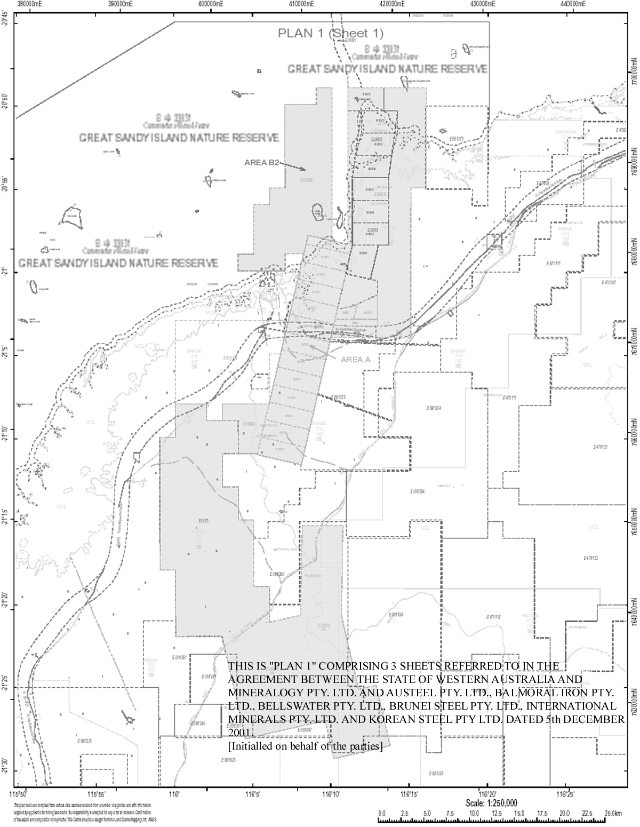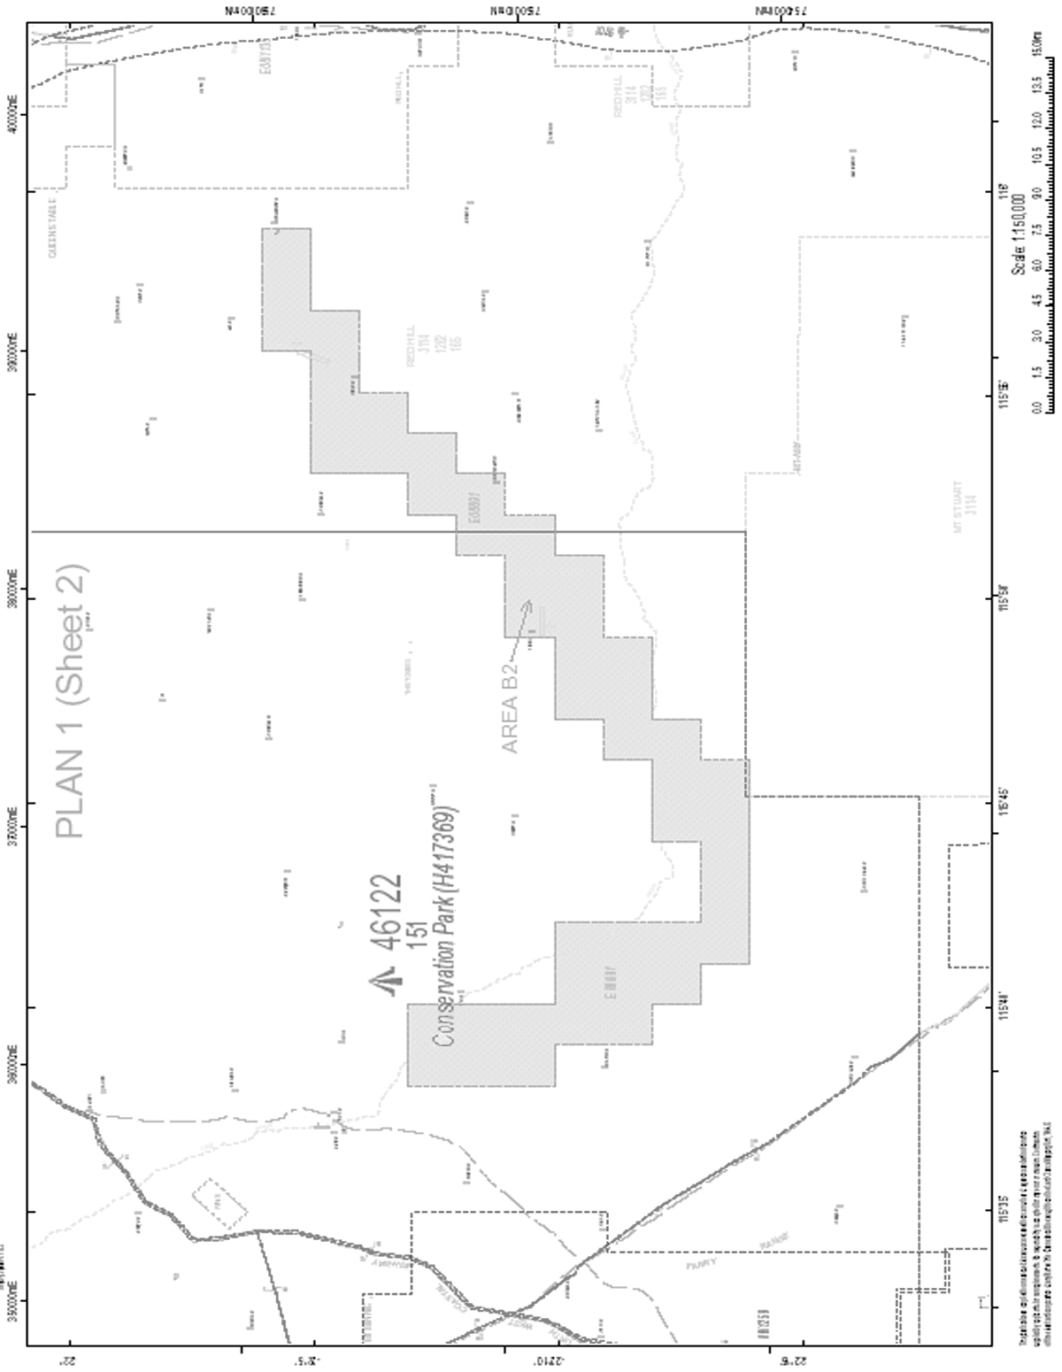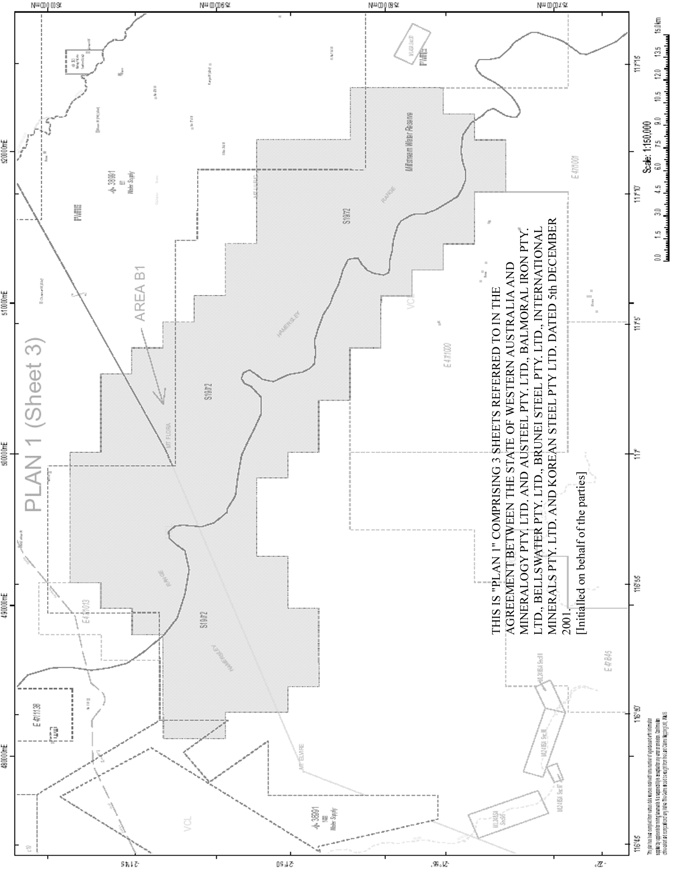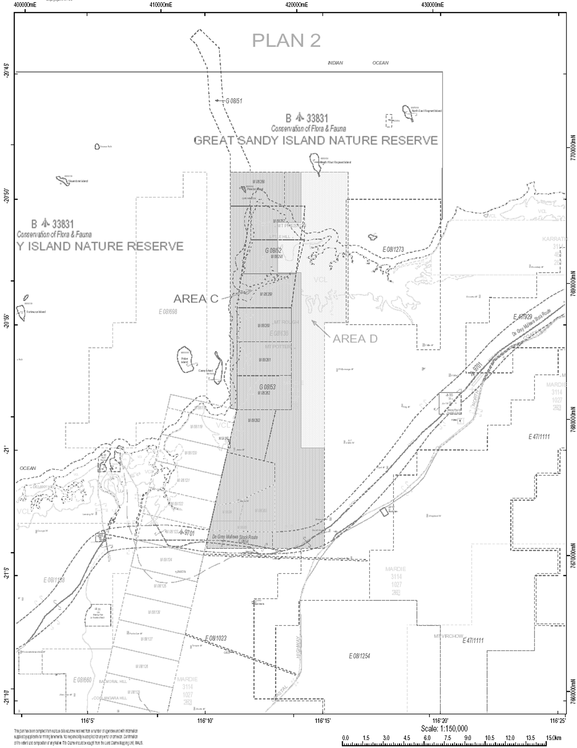

Schedule 2 — Variation agreement
[s. 3]

2008

THE HONOURABLE COLIN JAMES BARNETT
PREMIER OF THE STATE OF WESTERN AUSTRALIA

and

MINERALOGY PTY. LTD.
ACN 010 582 680

and

AUSTEEL PTY. LTD.
ACN 058 430 032
BALMORAL IRON PTY. LTD.
ACN 058 429 931
ANSHAN RESOURCES PTY. LTD.
ACN 058 429 977
KOREAN STEEL PTY. LTD.
ACN 058 429 600
SINO IRON PTY. LTD.
ACN 058 429 708
INTERNATIONAL MINERALS PTY. LTD.
ACN 058 341 638

IRON ORE PROCESSING (MINERALOGY PTY LTD) AGREEMENT 2002

RATIFIED VARIATION AGREEMENT

[Solicitor’s details]

THIS AGREEMENT is made the 14th day of November 2008

BETWEEN

THE HONOURABLE COLIN JAMES BARNETT MEc., MLA., Premier of the State of Western Australia, acting for and on behalf of the said State and its instrumentalities from time to time (State) of the first part

AND

MINERALOGY PTY. LTD. ACN 010 582 680 of Mineralogy House, Level 8, 135 Wickham Terrace, Spring Hill, Queensland (Company) of the second part

AND

AUSTEEL PTY. LTD. ACN 058 430 032, BALMORAL IRON PTY. LTD. ACN 058 429 931 and ANSHAN RESOURCES PTY. LTD. ACN 058 429 977 all of Mineralogy House, Level 8, 135 Wickham Terrace, Spring Hill, Queensland, KOREAN STEEL PTY. LTD. ACN 058 429 600 of 99 St Georges Terrace, Perth, Western Australia, SINO IRON PTY. LTD. ACN 058 429 708 of C/- Gilbert & Tobin, Level 37, 2 Park Street, Sydney, New South Wales and INTERNATIONAL MINERALS PTY. LTD. ACN 058 341 638 of Level 4, 5 Mill Street, Perth Western Australia (Co-Proponents) of the third part.

RECITALS

A. The State, the Company and the Co-Proponents are the parties to the agreement made 5 December 2001 which was ratified by the Iron Ore Processing (Mineralogy Pty Ltd) Agreement Act 2002. That agreement is referred to in this Agreement as the “Principal Agreement”.

B. The State, the Company and the Co-Proponents wish to vary the Principal Agreement as set out in this variation including:
(a) to allow Project Proponents to produce iron ore concentrates for sale within Australia or by export to overseas producers;
(b) to amend Area A, Area C and Area D as defined in the State Agreement; and
(c) to provide for the relinquishment by the Company of land to the State to facilitate the future development of multi user port facilities at Cape Preston outside Area A.

THE PARTIES AGREE AS FOLLOWS:

1. Subject to the context, the words and expressions used in this Agreement have the same meanings respectively as they have in and for the purpose of the Principal Agreement.

2. The State shall sponsor a Bill in the Parliament of Western Australia to ratify this Agreement and shall endeavour to secure its passage as an Act prior to 31 December 2008 or such later date as the parties may agree.

3. (a) Clause 4 of this Agreement shall not come into operation unless or until an Act passed in accordance with clause 2 of this Agreement ratifies this Agreement.

(b) If by 31 December 2008 or such later date as may be agreed pursuant to clause 2 of this Agreement, clause 4 of this Agreement has not come into operation then unless the parties hereto agree this Agreement shall cease and determine and none of the parties hereto shall have any claim against the other parties with respect to any matter or thing arising out of, done, performed or omitted to be done or performed under this Agreement.

4. The Principal Agreement is hereby varied:
(1) in clause 1:
(a) by inserting in the appropriate alphabetical positions the following new definitions;
“Access Act” means the Railways (Access) Act 1998;
“Access Code” means the Railways (Access) Code 2000;
“Access Minister” means the Minister in the Government of the State for the time being responsible for the administration of the Access Act;
“including” means “including, but not limited to”;
“Plan 3” and “Plan 4” mean respectively the plans marked “3” and “4” initialled by or on behalf of the parties hereto for the purpose of identification;
“Project 4” means a project or projects for the production of iron ore concentrates within Western Australia with subject to Clause 2(h) an initial minimum production capacity of six million tonnes per annum (or lesser amount approved by the Minister) from a mine or mines within Area A and an iron ore concentrates production facility located within Area A including expansions of projects the subject of approvals from time to time and may include inter alia a mine, concentrator, power station, desalination plant, port, pipelines and any other necessary facilities to enable iron ore concentrates to be produced transported and shipped for sale within Australia or for export to overseas purchasers including, subject to subclause (7) of Clause 11, as part of a blended product;
“Rail Safety Act” means the Rail Safety Act 1998;
“said State” means the State of Western Australia;
“Sino Iron” means Sino Iron Pty. Ltd. ACN 058 429 708 (formerly called Bellswater Pty. Ltd.) and includes its successors and permitted assigns;
“Sino Iron Project” means the project of the type of Project 1 the subject of proposals submitted by Sino Iron and the Company on 29 February 2008 and approved by the Minister under Clause 7 as modified, expanded or otherwise varied from time to time in accordance with this Agreement;
“variation date” means the date on which clause 4 of the variation agreement made on or about 14 November 2008 between the State, the Company and the Co-Proponents comes into operation;
(b) in the definition of “Ancillary Tenement” by deleting “and its application for miscellaneous licence 08/20” and substituting “, 08/63 and 08/74, applications by it for general purpose leases over land currently the subject of its general purpose lease 08/52 for a pellet plant or accommodation village or both and its applications for miscellaneous licences 08/20, 08/22 and 08/23”;”
(c) in the definition of “Area A”:
(i) by deleting in paragraph (a) “Sheet 1 of Plan 1” and substituting “Plan 3”;
(ii) by deleting in paragraph (a)(ii) “and 08/660” and substituting “, 08/660 and 08/1414”;
(iii) by inserting in paragraph (a)(iii) “exploration licence 08/1451 being” before “the exploration licence”; and
(iv) by deleting in paragraph (a)(vi) “Sheet 1 of Plan 1” and substituting “Plan 3”;
(d) in the definition of “Area C” by deleting “Plan 2” and substituting “Plan 4”;
(e) in the definition of “Area D”:
(i) by deleting “light blue” and substituting “green”; and
(ii) by deleting “Plan 2” and substituting “Plan 4”;
(f) in the definition of “iron ore concentrates” by deleting “mean” and substituting “means”;
(g) in the definition of “Mining Leases” by deleting “that have been dedicated to a Project” and substituting “the carrying out of mining of iron ore on all or part of which is authorised by an approved proposal”;
(h) in the definitions of “Project 1”, “Project 2” and “Project 3” by deleting “supply of a minor tonnage of iron ore concentrates for use as heavy media in the coal washing industry” and substituting “production of iron ore concentrates from iron ore mined as part of the Project for sale within Australia or for export to overseas purchasers including, subject to subclause (7) of Clause 11, as part of a blended product”; and
(i) in the definition of “Project” by deleting the first reference to “or Project 3” and substituting “, Project 3 or Project 4”;
(2) in clause 2:
(a) by inserting in paragraph (c) “and subclause” after “Clause”; and
(b) by, in paragraph (h):
(i) inserting “, or Project 4” after the first reference to “Project 3”; and
(ii) deleting “Project 3 or a combination thereof” and substituting “, Project 3 or Project 4 or a combination of Project 1, Project 2 or Project 3”;
(3) in clause 5(1) by deleting “its field” and substituting “the field (including drilling and sampling)”;
(4) by inserting after clause 5 the following new clauses 5A and 5B:
“Community and social benefits plan
5A. (1) In this Clause, the term “community and social benefits” includes:
(a) training and guaranteed employment for indigenous and non-indigenous persons living in the Pilbara region of the said State;
(b) regional development and local procurement of goods and services;
(c) contribution to community services and facilities; and
(d) a regionally based workforce.
(2) For the purposes of this Clause “Sino Iron Project” shall include the proposed production as part of it of 36 million tonnes per annum of iron ore concentrates for sale within Australia or for export to overseas purchasers.
(3) Sino Iron acknowledges the need for community and social benefits flowing from the Sino Iron Project.
(4) As soon as practicable after the variation date Sino Iron shall:
(a) consult, or as the case may be continue its consultations with, relevant local government or local governments with respect to the need for community and social benefits in relation to the developments proposed as part of the Sino Iron Project;
(b) following such consultation, prepare a plan which describes Sino Iron’s proposed strategies for achieving community and social benefits in connection with the developments proposed as part of the Sino Iron Project and such plan shall include a process for regular consultation by Sino Iron with the relevant local government or local governments in respect of the strategies; and
(c) submit to the Minister the plan prepared pursuant to subclause (4)(b) and confer with the Minister in respect of the plan.
(5) The Minister shall within one month after receipt of a plan submitted under subclause (4)(c), either notify Sino Iron that the Minister approves the plan as submitted or notify Sino Iron of any changes that the Minister requires be made to the plan. If Sino Iron is unwilling to accept the changes which the Minister requires it shall notify the Minister to that effect and either party may refer to arbitration hereunder the question of the reasonableness of the changes required by the Minister.
(6) The effect of an award made on an arbitration pursuant to subclause (5) shall be that the plan submitted by Sino Iron pursuant to subclause (4)(c) shall, with such changes required by the Minister under subclause (5) as the arbitrator determines to be reasonable (with or without modification by the arbitrator), be deemed to be the plan approved by the Minister under this Clause.
(7) During the continuance of this Agreement, Sino Iron shall implement the plan approved or deemed to be approved by the Minister under this Clause.
(8) Sino Iron shall report to the Minister about the results of its periodic ongoing consultation with the relevant local government or local governments in accordance with the plan approved or deemed to be approved by the Minister under this Clause and as soon as practicable after each such consultation takes place.
(9) The State acknowledges that the Company is intending to:
(a) establish as soon as practicable after commencement of shipping operations as part of the Sino Iron Project a Prescribed Private Fund (“the Fund”) as defined in section 995-1 of the Income Tax Assessment Act of 1997;
(b) include the advancement of medical research and the support of the indigenous communities in Western Australia (“the Objects”) as part of the objects of the Fund; and
(c) provide the Fund during the term of this Agreement with a total of $100,000,000 of benefits and grants to achieve the Objects.
Land to be the subject of this Agreement
5B. (1) Area A covers the areas of Fortescue and Cape Preston in the Pilbara region of the said State that the Company believes will satisfy requirements for development in the short to medium term after the variation date. Area B1 and Area B2 contain iron ore formations which are seen by the Company as having long term exploration and development potential.
(2) Subject to subclause (3) of Clause 19, the land to be granted pursuant to this Agreement, whether under the LA Act, the Mining Act or otherwise, will be drawn from within:
(a) Area A; and
(b) such other areas of land in the vicinity of Area A as the Minister, before the Project Proponents submit proposals in respect thereof, approves as land the Project Proponents may as part of the particular proposals and in accordance with but subject to this Agreement request the grant to the Company of leases, licences or other tenure over to support the undertaking of the particular Project.
(3) (a) The Company shall in accordance with the Mining Act or other relevant Act promptly lodge for registration surrenders in respect of Area D of all mining tenements and other titles, and withdrawals of all applications for mining tenements, which it then holds or as the case may be has made, over Area D upon at least 3 months notice from the Minister given not earlier than 36 months after the variation date. In consideration of the Company doing so the State shall upon such surrender or as soon as practicable thereafter grant or arrange to have granted to the Company an easement to allow the pipelines and communications cables then constructed as part of the Sino Iron Project within that part of Area D shown cross hatched on Plan 4 to be continue to be used, operated, maintained and repaired for a term determinable, if it has not already determined, upon the expiration of 6 months notice from the grantor of the easement if the Project Proponents for the Sino Iron Project cease (other than by reasons of force majeure) to operate the Sino Iron Project.
(b) Without limiting the Company’s obligations under the Mining Act consequent upon such surrenders the Company shall yield up Area D free of all improvements (excepting the pipelines and the communications cables to be the subject of the abovementioned easement and any road) in a state of repair and condition as shall be consistent with the obligations of the Project Proponents for the Sino Iron Project under the approved proposals for the Sino Iron Project and to the satisfaction of the Minister.”;
(5) in clause 6(1) by deleting in the second sentence “or Project 3 or a combination thereof as aforesaid” and substituting “, Project 3 or Project 4 or a combination of Project 1, Project 2 and/or Project 3 as described in the definition of Project in Clause 1. However, the production by Sino Iron or the Company and Sino Iron together of iron ore concentrates from iron ore mined from mining leases 08/123–08/125 may only be proposed (pursuant to Clause 8) as part of the Sino Iron Project.”;
(6) in clause 6(2):
(a) by deleting the words “recover and process” and substituting the words “recover, concentrate and (if applicable) process or blend”;
(b) by deleting in paragraph (a)(ii) all the words after “Clause 10 in respect of the project” and inserting the following new subparagraphs;
“(iii) any existing mining lease or leases, further mining leases or leases or other mining leases comprising part of Area A, or part thereof, from which the Project Proponents propose iron ore be mined as part of and for the purposes of the project and the amount of iron ore from such mining lease or leases to be assigned to the project; and
(iv) any Ancillary Tenement or part thereof which the Project Proponents propose be used for the purposes of the project;”;
(c) by deleting in paragraph (b) the words “for processing of iron ore” and substituting the words “for producing iron ore concentrates and for processing or blending of iron ore concentrates”;
(d) by inserting in paragraph (g) “(including as part of a blended product)” after “transportation of iron ore concentrates”;
(e) by deleting paragraph (l) and substituting the following new paragraph (l):
“(l) production of iron ore concentrates (including for sale within Australia or for export to overseas purchasers) and final products from iron ore concentrates by pelletising and/or direct reduction and/or steel making or, subject to subclause (7) of Clause 11, by blending and disposal of residues;”;
(f) by inserting in paragraph (m) “iron ore concentrates and” after “ship loading of”; and
(g) by deleting in paragraph (n) “and corridors for”;
(7) in clause 6(4):
(a) by inserting “or proposed” after “Use of existing” in the heading of clause 6(4);
(b) by inserting “proposed to be constructed or acquired by them or,” after “belonging to the Company or the Project Proponents or”; and
(c) by inserting the following new sentence:
“The Minister’s abovementioned consent will not be required for a Project 4 to provide for the use by its Project Proponents of any existing facilities equipment or services belonging to any Project Proponents in their capacity as Project Proponents for a project of the type of Project 1, Project 2, Project 3 or combination thereof as described in the definition of Project in Clause 1.”;
(8) by inserting after clause 6(4) the following new subclause (4a):
“(4a) The Project Proponents for a Project of the type of Project 1, Project 2, Project 3 or combination thereof as described in the definition of Project in Clause 1 may with the consent of the Minister propose, as part of their proposals under Clause 6 or Clause 8, the construction establishment or provision as the case may be as part of their Project of facilities, equipment or services as the case may be for use by Project Proponents of a particular Project 4 (whether current or proposed).”;
(9) by deleting clause 6(5) and substituting the following new subclause (5):
“(5) Proposals submitted pursuant to subclause (1) for Plant areas in respect of any area within Area C shall make reasonable provision for future third party use of port facilities as provided for in subclause (3) of Clause 21.”;
(10) in clause 7(2) by deleting in paragraph (a) “section 40(1)(b)” and substituting “Part IV”;
(11) in clause 9(2):
(a) by deleting “, dedication thereof to one of the Projects and, in any other case, surrender of the tenement by the Company” and substituting “it becomes a Mining Lease and in any other case surrender of the tenement by the Company”;
(b) by deleting in paragraph (c)(i) “any Ancillary Tenements,” and substituting “in respect of any Ancillary Tenements which are being used as part of a Project in accordance with approved proposals,”;
(c) by deleting “and” at the end of paragraph (c)(ii);
(d) by deleting in paragraph (c)(iii) “(not being a mining lease which has been dedicated to a Project)” and substituting “(not being a Mining Lease)”;
(e) by deleting the full stop at the end of paragraph (c)(iii) and substituting “; and”; and
(f) by inserting after paragraph (c)(iii) the following new paragraph (c)(iv):
“(iv) in respect of mining leases, the mining of iron ore (other than exploration, bulk sampling or testing) shall not be undertaken other than as part of a Project subject to and in accordance with this Agreement.”;
(12) in clause 9(5) by deleting “five” in paragraph (b) and substituting “ten”;
(13) in clause 9(6) by deleting “and as if the word “five” in paragraph (b) of subclause (5) were deleted and substituted by the word “ten” ”;
(14) in clause 9(7) by inserting “(excluding all Ancillary Tenements)” after “the aggregate area of Area A”;
(15) in clause 9(8):
(a) by deleting in paragraph (a) “or part thereof within Area A other than a mining lease dedicated to a Project or a mining lease granted pursuant to Clause 10” and substituting “within Area A other than a Mining Lease”;
(b) by deleting “or part thereof” in paragraph (a)(ii); and
(c) by deleting “or part thereof” in paragraph (c)(i);
(16) in clause 10(2):
(a) by deleting in paragraph (a) the words “becomes dedicated to a Project” and substituting the words “first becomes a Mining Lease”; and
(b) by deleting paragraph (b) and substituting the following new paragraph (b):
“(b) The parties acknowledge that more than one Project may be established in accordance with approved proposals upon an existing mining lease or further mining lease.”;
(17) by inserting after clause 10(2) the following new subclause (3a):
“Mining of iron ore
(3a) A Mining Lease shall, in addition to any covenants and conditions that may be imposed pursuant to the Mining Act or this Agreement, be subject to the condition that during the currency of this Agreement the mining of iron ore (other than exploration, bulk sampling or testing) shall not be undertaken other than as part of a Project subject to and in accordance with this Agreement.”;
(18) in clause 10(7) by inserting “or Ancillary Tenements” after “within the Mining Leases”;
(19) in clause 10(8) by deleting “[ ]” and substituting “2002”;
(20) in clause 11(3):
(a) by inserting “(including iron ore concentrates)” after “quantities of input, other iron ore”;
(b) by inserting “, and also showing such other information in relation to the abovementioned return as the Minister may from time to time reasonably require in regard to and to assist in verifying the calculation of royalties in accordance with subclause (1),” after “due date of the return”;
(21) in clause 11(6) by renumbering the existing paragraph (d) as paragraph (e) and inserting the following new paragraph (d):
“(d) “processed” in relation to iron ore concentrates means processed into pellets, DRI or steel as the case may be as part of a Project;”;
(22) by inserting after clause 11(6) the following new subclause (7):
“Blending of iron ore
(7) (a) Project Proponents may as part of their Project undertake within Area A the blending of iron ore concentrates produced as part of their Project with iron ore owned by any one or more of them or of a third party or parties and mined from mining tenements or other mining titles within the Pilbara outside Area A, B1 and B2 (“Non-Agreement ore”) for the purpose of shipping such blended ore through port facilities established under this Agreement.
(b) The Project Proponents must establish and keep in place adequate systems and controls, to the reasonable satisfaction of the Minister for Mines, for the correct apportionment between each of the relevant mining leases or other mining titles of the quantities of iron ore concentrates and other iron ore being blended and which systems and controls monitor production, concentrating, transportation, stockpiling and shipping of all such ore.
(c) If any blending occurs as contemplated by this subclause then for the purposes of calculating the royalty payable as provided in this Clause 11 on the iron ore concentrates produced as part of the Project and used in the admixture, the gross sale price of the blended product as set out in the invoices relating to the sale (and converted if necessary to Australian currency in accordance with the Mining Regulations 1981) shall be apportioned to those iron ore concentrates (as their gross invoice value) in the same proportion as the total amount of iron in those iron ore concentrates bears to the total amount of iron in the blended product.
(d) To avoid doubt the parties acknowledge that the mining, concentrating, processing and transport of Non-Agreement ore to Project Proponents within Area A for blending as referred to above will not be part of Projects under this Agreement.”;
(23) in clause 14 by deleting in paragraph (a) all the words after “generate electricity”, inserting a colon followed by the following new subparagraphs:
“(i) for their activities on the Mining Leases and at the Plant areas;
(ii) if the Company so desires, for the activities of other Project Proponents on the Mining Leases and at the Plant areas as permitted under subclauses (4) and (4a) of Clause 6; and
(iii) if the Company so desires and with the Minister’s consent given before submission and approval of their abovementioned proposals (which consent may be given subject to a condition as to the amount to be generated for such purpose), for supply to third parties or other third parties as the case may be; and”;
(24) in clause 20(1) by deleting “or dedicated to the Project” and substituting “or to be mined as part of the Project”;
(25) in clause 21(3):
(a) by inserting “and in accordance with the principles for access contained in section 6(4) of the Competition Principles Agreement made on 11 April 1995 between the Commonwealth, New South Wales, Victoria, Queensland, Western Australia, South Australia, Tasmania, the Australian Capital Territory and the Northern Territory” after “the Company or the Project Proponents as the case may be)”;
(b) by inserting “(excepting the Export Wharves and Associated Facilities)” before “PROVIDED THAT”;
(c) by inserting “in the reasonable opinion (after consultation with the Project Proponents) of an Independent Person” after “PROVIDED THAT such use shall not”;
(d) by deleting the full stop at the end of this subclause and inserting the following:
“(which approval shall not be unreasonably withheld). For the purpose of this subclause:
(a) an “Independent Person” means such person as is agreed upon between the Company and the State or third parties as the case may be seeking the abovementioned use and in default of agreement within one month of the Minister requiring such person to be agreed upon then as nominated by the Minister; and
(b) the “Export Wharves and Associated Facilities” means the wharf or wharves, stockpile areas, conveyors and ship loaders constructed or provided by the Company and the Project Proponents or either of them at Cape Preston for the export from the said State of iron ore concentrates and other final products produced as part of a Project.
The Company and such of the State or third parties as the case may be seeking the abovementioned use shall each pay one half of the Independent Person’s costs and expenses.”;
(26) by inserting after clause 21(4) the following new subclause (5):
“Access pursuant to legislation
(5) The Company must, during the currency of this Agreement, consult with and keep the State fully informed concerning any steps that the Company proposes to take or is taking, or concerning any steps which the Company is aware any other person proposes to take or is taking, to have the wharf and port installations wharf machinery and equipment and wharf and port services and facilities referred to in subclause (2) (including the Export Wharves and Associated Facilities) made subject to Part III of the Trade Practices Act 1974.”;
(27) in clause 22(1):
(a) by deleting “and operated”; and
(b) by deleting “thereto” and substituting “to its construction and operation”;
(28) in clause 22(2):
(a) by inserting “and in accordance with approved proposals, the Rail Safety Act and” after “Subject to”; and
(b) by deleting “shall operate the said railway” and substituting “shall operate or ensure the said railway is operated”;
(29) in clause 22(3):
(a) by deleting “operate and maintain the said railway” and substituting “keep the said railway in operation and operated and maintained in”;
(b) by deleting “1998”; and
(c) by inserting the at end of this subclause:
“Without limiting the generality of the foregoing provisions the Company shall during the continuance of this Agreement:
(a) ensure that the obligations imposed under the Rail Safety Act on an owner and an operator (as those terms are therein defined) are complied with in connection with the said railway and (from when the Access Act and Access Code apply to the said railway) ensure that the obligations imposed under the Access Act and the Access Code on a railway owner (as that term is therein defined) are complied with in connection with the said railway; and
(b) shall not at any time without the prior consent of the Minister dismantle, sell or otherwise dispose of any part or parts of the said railway or permit this to occur, other than for the purpose of maintenance, repair, upgrade or renewal.
Nothing in this Agreement shall be construed to exempt the Company or any other person from compliance with the Rail Safety Act and the Access Act and the Access Code or limit their application to the Company’s or Project Proponents’ operations generally.”;
(30) by inserting after clause 22(5) the following new subclause (6):
“Access Act and Code
(6) (a) The Company shall, during the continuance of this Agreement and until the Access Act and the Access Code are applied to and in respect of the said railway and associated roads which provide access to the said railway, notify the Minister of all written requests made by third parties to the Company for access to the said railway and associated roads which provide access to the said railway and as soon as practicable after such requests are made.
(b) The Minister shall provide to the Access Minister a copy of each notification from the Company as soon as practicable after such notification is received for consideration by the Access Minister as to whether or not in the Access Minister’s discretion the Access Act and the Access Code should be applied to and in respect of the said railway and associated roads which provide access to the said railway.
(c) The Company acknowledges that the Access Act and the Access Code may during the continuance of this Agreement be applied to and in respect of the said railway and associated roads which provide access to the said railway (but not to the Company’s rolling stock, rolling stock maintenance facilities, office buildings, housing, freight centres, terminal yards and depots and any other facilities which are not railway infrastructure (as that term is defined in the Access Act).”;
(31) by deleting clause 25 Rating;
(32) by inserting after clause 28(2) the following new subclause (3):
“(3) (a) For the purposes of this subclause (3) the “State” includes the Minister, the Minister for Mines, any other Minister for the time being in the Government of the State, any department for the time being of the Government of the State, any governmental or semi-governmental body, any statutory authority or agency and the agents, servants, employees and contractors from time to time of each of them.
(b) Except as otherwise provided in this Agreement the State may in respect of a Project or proposed Project communicate directly with any Project Proponent or proposed Project Proponent for that Project without involving any other Project Proponent or proposed Project Proponent for that Project. However, such communication shall not bind such other Project Proponent or proposed Project Proponent.”;
(33) in clause 30(2):
(a) by deleting “Except as regards the land referred to in paragraph (b) of this subclause, the” and substituting “The”;
(b) by deleting paragraph (b) and the designation “(a)” before the first paragraph;
(34) by inserting after clause 31(1) the following new subclause (1a):
“(1a) The Company will advise the Minister within 30 days after it ceases to beneficially hold 50% of the voting rights in a Co-Proponents of that occurrence together with details of the new holder or holders and their respective holdings of voting rights.”;
(35) in clause 33(1) by deleting “The” and substituting “Subject to subclause (1a) the”;
(36) by inserting after subclause 33(1) the following new subclause (1a):
“(1a) Subclause (1) does not apply to the obligation to construct the pellet plant approved for construction as part of the Sino Iron Project.”; and
(37) by deleting 33(3) and substituting the following new subclause (3):
“(3) The party whose performance of obligations is affected by any of the said events or circumstances shall:
(a) promptly give notice to the other party of the event or circumstance;
(b) consult with the other party and promptly provide the other party with all such information as may be reasonably required by the other party to satisfy itself as to the existence of the events or circumstances; and
(c) shall use its best endeavours to minimise the effects of such causes as soon as possible after the occurrence.”
5. Upon clause 4 of this Agreement coming into operation (“variation date”):
(1) notwithstanding the provisions of the Mining Act 1978 and the Mining Regulations 1981:
(a) the Company’s exploration licence 08/636 shall be deemed to have been surrendered on the variation date in relation to that part of it coloured red on Sheet 1 of Plan 5; and
(b) the Company’s general purpose lease 08/52 shall be deemed to have been surrendered on the variation date in relation to that part of it coloured green on Sheet 2 of Plan 5; and
(c) the Company’s application for general purpose lease 08/74 shall be deemed to have lapsed in relation to that part of it coloured brown on Sheet 2 of Plan 5; and
(2) the Company shall, in the manner provided in regulation 59 of the Mining Regulations 1981, mark out the land that remains the subject of its application for general purpose lease 08/74 as soon as may be practicable and such marking in that manner shall be valid notwithstanding it is done after the application for the general purpose lease has been made.
For the purpose of this clause 5 “Plan 5” means the plan marked “5” (comprising Sheet 1 and Sheet 2) initialled by and on behalf of the parties for the purpose of identification.
6. Subject to the Environmental Protection Act 1986 and to clause 4 of this Agreement coming into operation, the State shall cause to be granted to the Company:
(1) its application for general purpose lease 08/63 as soon as practicable after:
(a) an indigenous land use agreement with the native title party or parties affected by its grant is entered into and registered under the Native Title Act 1993 (Commonwealth) (“NTA”); and
(b) that native title party or those native title parties as the case may be withdraw all objections previously made by it or them under the NTA in respect of the grant of that application and advise the State in writing that it or they no longer wish to pursue the objections previously made by it or them under the Mining Act 1978 (“Mining Act”) in respect of the grant of that application,
and upon such reasonable terms and conditions as the Minister for the time being responsible for the administration of the Mining Act (“Minister for Mines”) shall determine; and
(2) its application for general purpose lease 08/74 (less the area lapsed under clause 5(1)(c) of this Agreement) as soon as practicable after:
(a) clause 5(2) of this Agreement has been complied with;
(b) an indigenous land use agreement with the native title party or parties affected by its grant is entered into and registered under the NTA;
(c) that native title party or those native title parties as the case may be withdraw all objections previously made by it or them under the NTA in respect of the grant of that application;
(d) the Warden’s Court proceedings in respect of the proposed grant to this application are completed and a recommendation of the mining registrar or Warden as required by the Mining Act is provided to the Minister for Mines; and
(e) that native title party or those native title parties advise the State in writing that it or they no longer wish to pursue the objections previously made by it or them under the Mining Act in respect of the grant of that application,
and upon such reasonable terms and conditions as the Minister for Mines shall determine.
EXECUTED as a deed.
SIGNED by THE HONOURABLE )
COLIN JAMES BARNETT )
in the presence of: ) [Signature]

[Signature]
Witness

Name Sean David

SIGNED by MINERALOGY )
PTY. LTD. ACN 010 582 680 by its )
Attorney Murray R K Wheater )
under Power of Attorney dated )
12 November 2008 who )
declared that he has no notice of )
revocation of the said Power of Attorney )
in the presence of: ) [Signature]

[Signature]
Witness

Name Paul Sartori

SIGNED by AUSTEEL PTY. LTD. )
ACN 058 430 032 by its Attorney )
Murray R K Wheater )
under Power of Attorney dated )
12 November 2008 who )
declared that he has no notice of )
revocation of the said Power of Attorney )
in the presence of: ) [Signature]

[Signature]
Witness

Name: Paul Sartori

SIGNED by BALMORAL IRON )
PTY. LTD. ACN 058 429 931 by its )
Attorney Murray R K Wheater )
under Power of Attorney dated )
12 November 2008 who )
declared that he has no notice of )
revocation of the said Power of Attorney )
in the presence of: ) [Signature]

[Signature]
Witness

Name Paul Sartori

SIGNED by ANSHAN RESOURCES )
PTY. LTD. ACN 058 429 977 by its )
Attorney Murray R K Wheater )
under Power of Attorney dated )
12 November 2008 who )
declared that he has no notice of )
revocation of the said Power of Attorney )
in the presence of: ) [Signature]

[Signature]
Witness

Name Paul Sartori

SIGNED by KOREAN STEEL
PTY. LTD. ACN 058 429 600 by its )
Attorney Rick Joseph Malone )
under Power of Attorney dated )
5 November 2008 who )
declared that he has no notice of )
revocation of the said Power of Attorney )
in the presence of: ) [Signature]

[Signature]
Witness

Name Philip Richard Scott

SIGNED by SINO IRON PTY. LTD. )
ACN 058 429 708 by its Attorney )
Rick Joseph Malone )
under Power of Attorney dated )
5 November 2008 who )
declared that he has no notice of )
revocation of the said Power of Attorney )
in the presence of: ) [Signature]

[Signature]
Witness

Name Catherine Ann Pinchin

SIGNED by INTERNATIONAL )
MINERALS PTY. LTD. )
ACN 058 341 638 by its Attorney )
Murray R K Wheater )
under Power of Attorney dated )
12 November 2008 who )
declared that he has no notice of )
revocation of the said Power of Attorney )
in the presence of: ) [Signature]

[Signature]
Witness

Name Paul Sartori

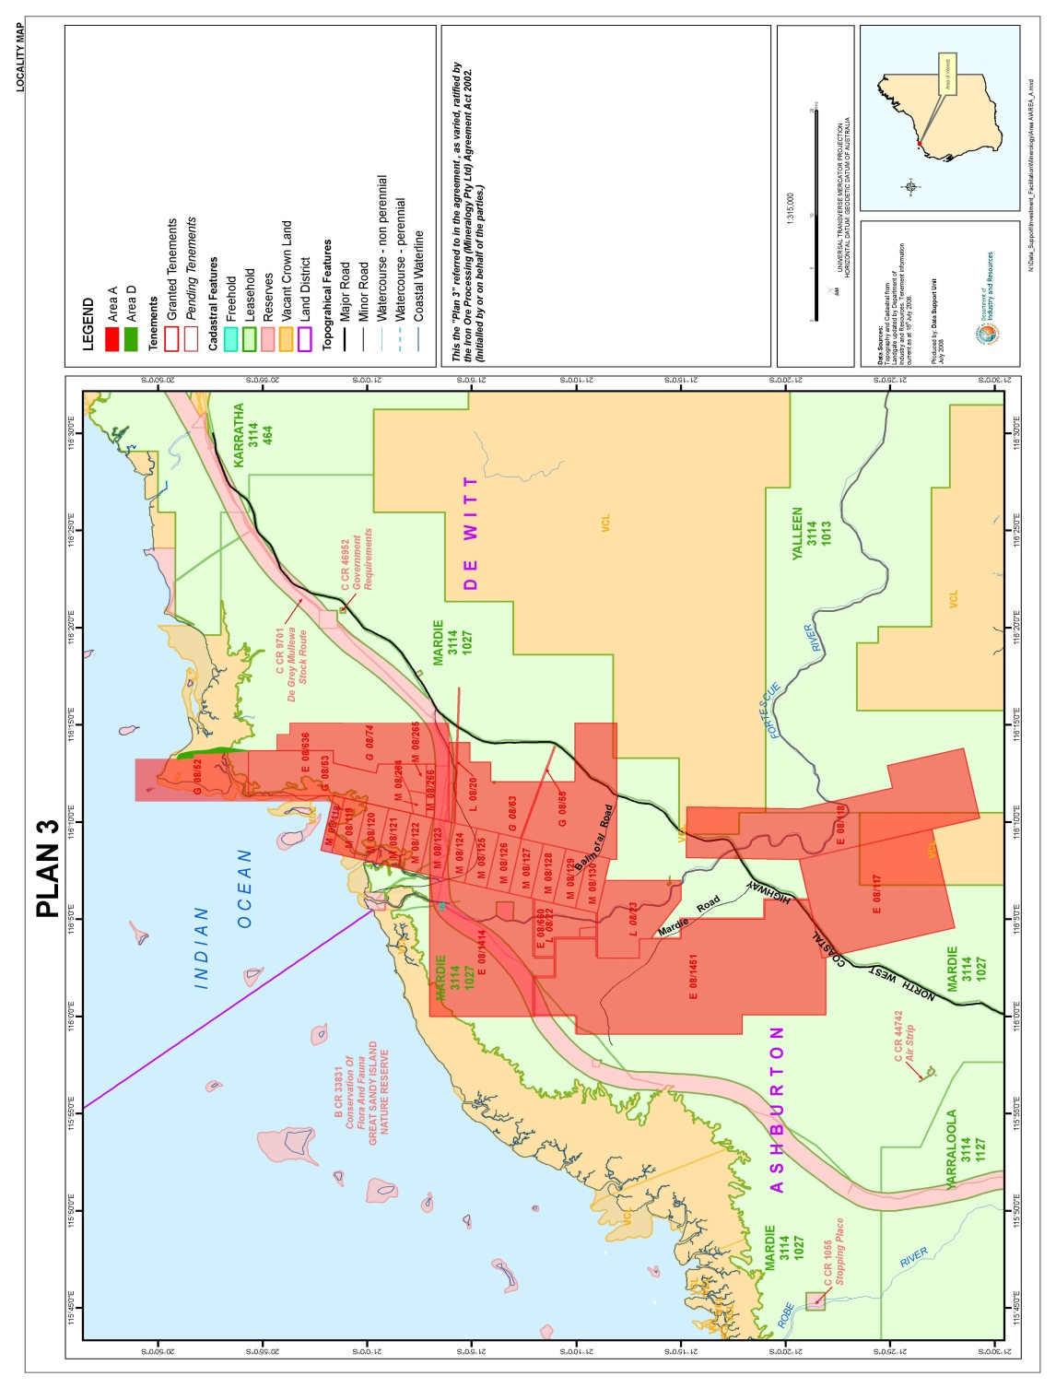

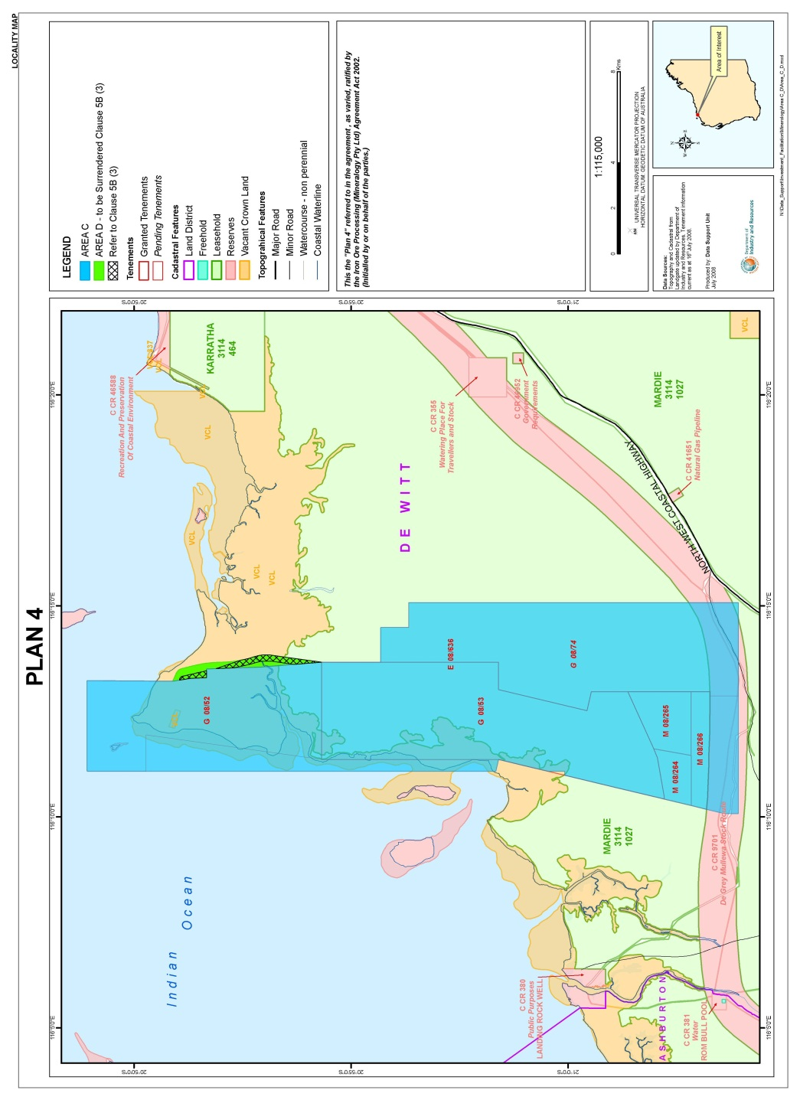

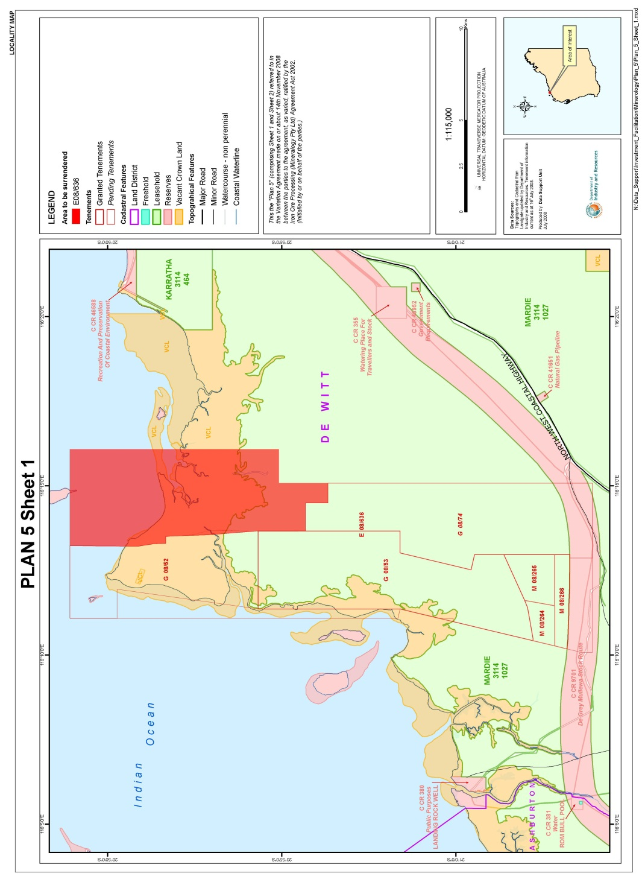

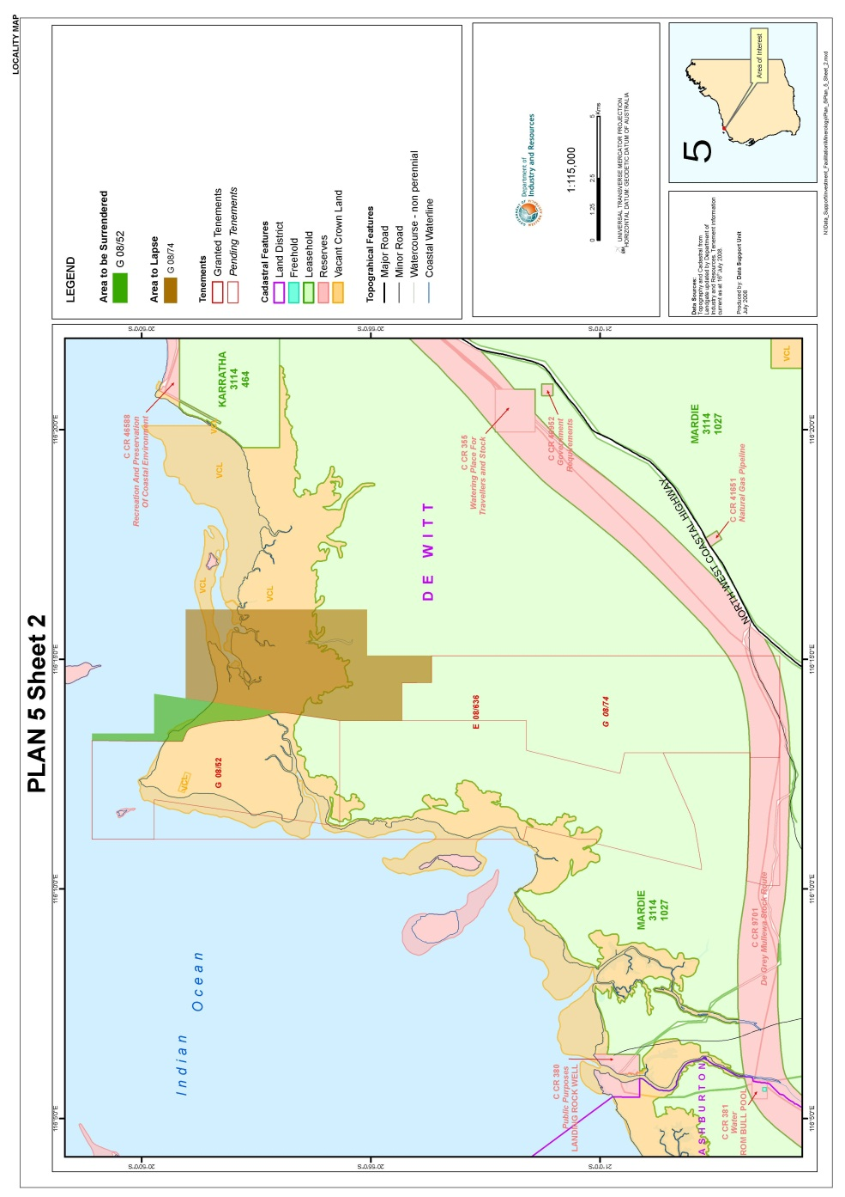
[Schedule 2 inserted: No. 48 of 2008 s. 6.]

Notes
¹ This is a compilation of the Iron Ore Processing (Mineralogy Pty. Ltd.) Agreement Act 2002 and includes the amendments made by the other written laws referred to in the following table.

Compilation table
Short title | Number and Year | Assent | Commencement
Iron Ore Processing (Mineralogy Pty. Ltd.) Agreement Act 2002 | 26 of 2002 | 24 Sep 2002 | 24 Sep 2002 (see s. 2)
Iron Ore Processing (Mineralogy Pty. Ltd.) Agreement Amendment Act 2008 | 48 of 2008 | 10 Dec 2008 | s. 1 and 2: 10 Dec 2008 (see s. 2(a));  Act other than s. 1 and 2: 11 Dec 2008 (see s. 2(b))

Defined terms

[This is a list of terms defined and the provisions where they are defined. The list is not part of the law.]
Defined term Provision(s)
the Agreement 3
variation agreement 3

